## MARCH 2019 SPACE ECONOMY NEWS -JAD

<https://spacenews.com/>

[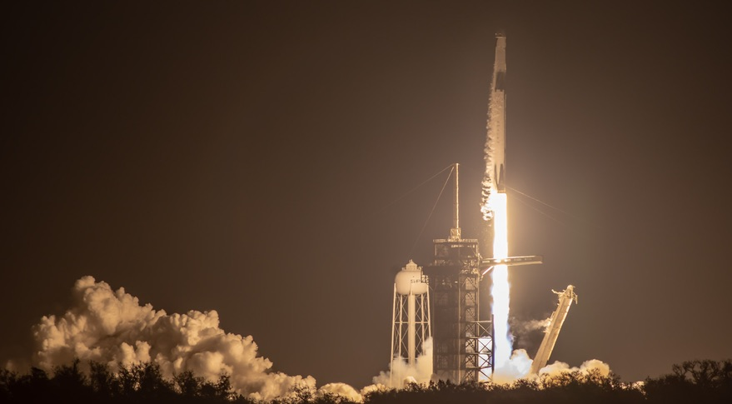](https://spacenews.com/falcon-9-launches-crew-dragon-on-key-test-flight/)

[CIVIL](https://spacenews.com/section/civil/) [COMMERCIAL](https://spacenews.com/section/commercial/)

# [Falcon 9 launches Crew Dragon on key test flight](https://spacenews.com/falcon-9-launches-crew-dragon-on-key-test-flight/)

[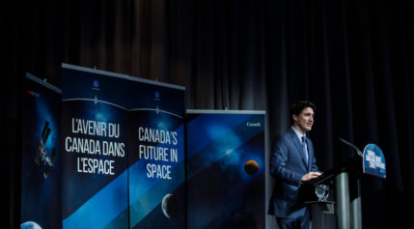](https://spacenews.com/canada-becomes-first-nation-to-formally-commit-to-nasas-lunar-gateway/)

[CIVIL](https://spacenews.com/section/civil/)

# [Canada becomes first nation to formally commit to NASA’s lunar Gateway](https://spacenews.com/canada-becomes-first-nation-to-formally-commit-to-nasas-lunar-gateway/)

[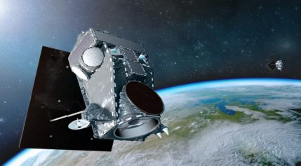](https://spacenews.com/maxar-to-retain-but-restructure-geo-satellite-business/)

[COMMERCIAL](https://spacenews.com/section/commercial/)

# [Maxar to retain but restructure GEO satellite business](https://spacenews.com/maxar-to-retain-but-restructure-geo-satellite-business/)

* [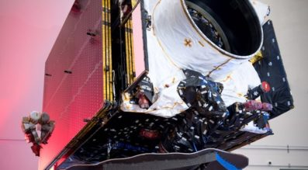](https://spacenews.com/maxar-cutting-jobs-to-help-stem-1-2-billion-loss-stabilize-satellite-division/)

[COMMERCIAL](https://spacenews.com/section/commercial/)

# [Maxar cutting jobs to help stem $1.2 billion loss, stabilize satellite division](https://spacenews.com/maxar-cutting-jobs-to-help-stem-1-2-billion-loss-stabilize-satellite-division/)

Maxar Technologies, which will lay off more than 200 people as it seeks to return to profitability, says the struggling satellite division it decided to keep will need to bring in roughly $500 million this year to break even.

* [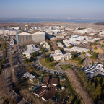](https://spacenews.com/foust-forward-the-government-shutdowns-shadow-on-commercial-space/)

[FROM THE MAGAZINE](https://spacenews.com/special-feature/from-the-magazine/)

# [Foust Forward | The government shutdown’s shadow on commercial space](https://spacenews.com/foust-forward-the-government-shutdowns-shadow-on-commercial-space/)

* [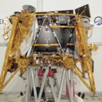](https://spacenews.com/spaceil-back-on-course-for-the-moon-after-computer-glitch/)

[COMMERCIAL](https://spacenews.com/section/commercial/)

# [SpaceIL back on course for the moon after computer glitch](https://spacenews.com/spaceil-back-on-course-for-the-moon-after-computer-glitch/)

* [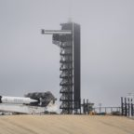](https://spacenews.com/more-work-ahead-for-crew-dragon-after-test-flight/)

[CIVIL](https://spacenews.com/section/civil/) [COMMERCIAL](https://spacenews.com/section/commercial/)

# [More work ahead for Crew Dragon after test flight](https://spacenews.com/more-work-ahead-for-crew-dragon-after-test-flight/)

* [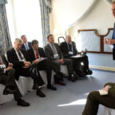](https://spacenews.com/space-force-proposal-officially-sent-to-capitol-hill-now-come-the-questions/)

[MILITARY](https://spacenews.com/section/military/) [POLICY & POLITICS](https://spacenews.com/section/policy-politics/)

# [Space Force proposal officially sent to Capitol Hill, now come the questions](https://spacenews.com/space-force-proposal-officially-sent-to-capitol-hill-now-come-the-questions/)

* [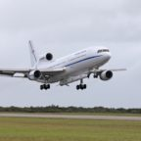](https://spacenews.com/pegasus-woes-continue-to-delay-nasa-mission/)

[CIVIL](https://spacenews.com/section/civil/) [LAUNCH](https://spacenews.com/section/launch/)

# [Pegasus woes continue to delay NASA mission](https://spacenews.com/pegasus-woes-continue-to-delay-nasa-mission/)

* [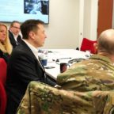](https://spacenews.com/air-force-laying-groundwork-for-future-military-use-of-commercial-megaconstellations/)

[COMMERCIAL](https://spacenews.com/section/commercial/) [MILITARY](https://spacenews.com/section/military/)

# [Air Force laying groundwork for future military use of commercial megaconstellations](https://spacenews.com/air-force-laying-groundwork-for-future-military-use-of-commercial-megaconstellations/)

* [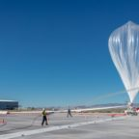](https://spacenews.com/world-view-hires-new-ceo/)

[COMMERCIAL](https://spacenews.com/section/commercial/)

# [World View hires new CEO](https://spacenews.com/world-view-hires-new-ceo/)

* [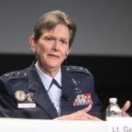](https://spacenews.com/is-the-space-development-agency-a-threat-to-smc/)

[SN MILITARY.SPACE](https://spacenews.com/special-feature/sn-military-space/)

# [Is the Space Development Agency a threat to SMC?](https://spacenews.com/is-the-space-development-agency-a-threat-to-smc/)

* [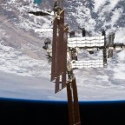](https://spacenews.com/senate-bill-seeks-extension-of-the-space-station/)

[CIVIL](https://spacenews.com/section/civil/) [POLICY & POLITICS](https://spacenews.com/section/policy-politics/)

# [Senate bill seeks extension of the space station](https://spacenews.com/senate-bill-seeks-extension-of-the-space-station/)

* [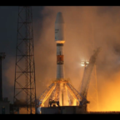](https://spacenews.com/first-six-oneweb-satellites-launch-on-soyuz-rocket/)

[COMMERCIAL](https://spacenews.com/section/commercial/) [LAUNCH](https://spacenews.com/section/launch/)

# [OneWeb’s first six satellites in orbit following Soyuz launch](https://spacenews.com/first-six-oneweb-satellites-launch-on-soyuz-rocket/)

* [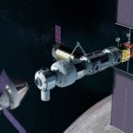](https://spacenews.com/shutdown-to-delay-first-element-of-nasas-lunar-gateway/)

[CIVIL](https://spacenews.com/section/civil/)

# [Shutdown to delay first element of NASA’s lunar Gateway](https://spacenews.com/shutdown-to-delay-first-element-of-nasas-lunar-gateway/)

* [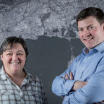](https://spacenews.com/iceye-expands-staff-to-prepare-for-constellation/)

[COMMERCIAL](https://spacenews.com/section/commercial/)

# [Iceye expands staff to prepare for constellation](https://spacenews.com/iceye-expands-staff-to-prepare-for-constellation/)

* [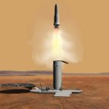](https://spacenews.com/nasa-unlikely-to-return-mars-samples-in-the-2020s/)

[CIVIL](https://spacenews.com/section/civil/)

# [NASA unlikely to return Mars samples in the 2020s](https://spacenews.com/nasa-unlikely-to-return-mars-samples-in-the-2020s/)

* [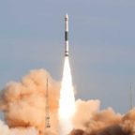](https://spacenews.com/chinese-state-owned-firms-preparing-to-launch-new-commercial-rockets/)

[LAUNCH](https://spacenews.com/section/launch/)

# [Chinese state-owned firms preparing to launch new commercial rockets](https://spacenews.com/chinese-state-owned-firms-preparing-to-launch-new-commercial-rockets/)

* [](https://spacenews.com/op-ed-sustainability-on-earth-depends-on-our-exploration-of-space/)

# [Op-ed | Sustainability on Earth depends on our exploration of space](https://spacenews.com/op-ed-sustainability-on-earth-depends-on-our-exploration-of-space/)

# NASA

# **Latest NASA News Releases**

### **Results (1667)**

### [**NASA, SpaceX Launch First Flight Test of Space System Planned for Crew**](https://www.nasa.gov/press-release/nasa-spacex-launch-first-flight-test-of-space-system-designed-for-crew)

March 2, 2019 - For the first time in history, a commercially-built and operated American crew spacecraft and rocket, which launched from American soil, is on its way to the International Space Station.

### [**NASA Secures First International Partnership for Lunar Gateway**](https://www.nasa.gov/press-release/nasa-secures-first-international-partnership-for-moon-to-mars-lunar-gateway)

Feb. 28, 2019 - The following is a statement from NASA Administrator Jim Bridenstine on the announcement Thursday by Canadian Prime Minister Justin Trudeau about Canada’s support for the Gateway lunar outpost and deep space exploration:

### [**NASA Awards Contract for Construction Services**](https://www.nasa.gov/press-release/nasa-awards-contract-for-construction-services)

Feb. 28, 2019 - NASA has awarded a contract to 13 U.S. companies for building construction services at several California facilities.

### [**NASA Awards Contract for Protective Services at Houston Facilities**](https://www.nasa.gov/press-release/nasa-awards-contract-for-protective-services-at-houston-facilities)

Feb. 28, 2019 - NASA has awarded a contract to Praetorian Standard Inc., of Fayetteville, North Carolina, a service disabled veteran-owned small business, to provide comprehensive security services at the agency’s Johnson Space Center in Houston, as well as facilities managed by Johnson.

### [**NASA Selects Mission to Study Space Weather from Space Station**](https://www.nasa.gov/press-release/nasa-selects-mission-to-study-space-weather-from-space-station)

Feb. 26, 2019 - NASA has selected a new mission that will help scientists understand and, ultimately, forecast the vast space weather system around our planet.

### [**New ‘NASA Science Live’ Program Premieres This Week**](https://www.nasa.gov/press-release/new-nasa-science-live-program-premieres-this-week)

Feb. 25, 2019 - NASA invites you to take a behind-the-scenes look at how the agency explores Earth and outer space with a new monthly television series that premieres this week.

### [**NASA Awards Support Services Contract for Exploration Ground Systems**](https://www.nasa.gov/press-release/nasa-awards-support-services-contract-for-exploration-ground-systems-program)

Feb. 22, 2019 - NASA has selected LJT & Associates, Incorporated of Columbia, Maryland, to provide support services to the Exploration Ground Systems (EGS) Program at the agency’s Kennedy Space Center in Florida.

### [**NASA Renames Facility in Honor of ‘Hidden Figure’ Katherine Johnson**](https://www.nasa.gov/press-release/nasa-renames-facility-in-honor-of-hidden-figure-katherine-johnson)

Feb. 22, 2019 - NASA has redesignated its Independent Verification and Validation (IV&V) Facility in Fairmont, West Virginia, as the Katherine Johnson Independent Verification and Validation Facility, in honor of the West Virginia native and NASA "hidden figure."

### [**NASA Administrator Statement on Israeli Moon Mission**](https://www.nasa.gov/press-release/nasa-administrator-statement-on-israeli-moon-mission)

Feb. 22, 2019 - The following is a statement from NASA Administrator Jim Bridenstine on Thursday’s launch of Israel’s first mission beyond Earth’s orbit. SpaceIL’s lander blasted off from Cape Canaveral Air Force Station in Florida, and now is on its way to becoming the first commercial lander to reach the Moon’s surface.

### [**NASA Selects Experiments for Possible Lunar Flights in 2019**](https://www.nasa.gov/press-release/nasa-selects-experiments-for-possible-lunar-flights-in-2019)

Feb. 21, 2019 - NASA has selected 12 science and technology demonstration payloads to fly to the Moon as early as the end of this year, dependent upon the availability of commercial landers.

### [**NASA-Funded Research Creates DNA-like Molecule**](https://www.nasa.gov/press-release/nasa-funded-research-creates-dna-like-molecule-to-aid-search-for-alien-life)

Feb. 21, 2019 - In a research breakthrough funded by NASA, scientists have synthesized a molecular system that, like DNA, can store and transmit information. This unprecedented feat suggests there could be an alternative to DNA-based life, as we know it on Earth – a genetic system for life that may be possible on other worlds.

### [**NASA to Provide Coverage of SpaceX Commercial Crew Flight Test**](https://www.nasa.gov/press-release/nasa-to-provide-coverage-of-spacex-commercial-crew-flight-test)

Feb. 20, 2019 - NASA will provide coverage of the upcoming prelaunch and launch activities for the SpaceX Demo-1 flight test to the International Space Station for the agency’s Commercial Crew Program, which is working with the U.S. aerospace industry to launch astronauts on American rockets and spacecraft from American soil for the first time since 2011.

### [**New NASA Book Shares Beauty of Earth from Space**](https://www.nasa.gov/press-release/new-nasa-book-shares-beauty-of-earth-from-space)

Feb. 20, 2019 - Swirling white clouds, deep blue oceans and multicolored landscapes bring to life the pages of NASA’s new 168-page book “Earth,” a collection of dramatic images captured by Earth-observing satellites. The book is available now in hardcover and ebook, and online with interactive features.

### [**NASA Tests Urban Drone Traffic Management in Nevada, Texas**](https://www.nasa.gov/press-release/nasa-tests-urban-drone-traffic-management-in-nevada-texas)

Feb. 19, 2019 - NASA has selected two organizations to host the final phase of its four-year series of increasingly complicated technical demonstrations involving small Unmanned Aircraft Systems (UAS), commonly known as drones.

### [**Florida Students to Speak with NASA Astronaut Aboard Space Station**](https://www.nasa.gov/press-release/florida-students-to-speak-with-nasa-astronaut-aboard-international-space-station)

Feb. 15, 2019 - University and high school students from Florida will have an opportunity to talk with a NASA astronaut on the International Space Station next week.

### [**NASA Selects New Mission to Explore Origins of Universe**](https://www.nasa.gov/press-release/nasa-selects-new-mission-to-explore-origins-of-universe)

Feb. 13, 2019 - NASA has selected a new space mission that will help astronomers understand both how our universe evolved and how common are the ingredients for life in our galaxy’s planetary systems.

### [**NASA's Record-Setting Opportunity Rover Mission on Mars Comes to End**](https://www.nasa.gov/press-release/nasas-record-setting-opportunity-rover-mission-on-mars-comes-to-end)

Feb. 13, 2019 - One of the most successful and enduring feats of interplanetary exploration, NASA's Opportunity rover mission is at an end after almost 15 years exploring the surface of Mars and helping lay the groundwork for NASA’s return to the Red Planet.

### [**NASA Astronauts Available for Interviews Before Space Station Mission**](https://www.nasa.gov/press-release/nasa-astronauts-available-for-interviews-before-space-station-mission-0)

Feb. 13, 2019 - NASA astronauts Nick Hague and Christina Koch will be available for live satellite interviews Friday, Feb. 22, as they undergo final training before their launch to the International Space Station, scheduled for March 14.

### [**NASA to Share Results of Effort to Recover Mars Opportunity Rover**](https://www.nasa.gov/press-release/nasa-to-share-results-of-effort-to-recover-mars-opportunity-rover)

Feb. 12, 2019 - NASA will discuss the status of its Mars Exploration Rover (MER) Opportunity in a media briefing at 2 p.m. EST (11 a.m. PST) Wednesday, Feb. 13, from the agency’s Jet Propulsion Laboratory (JPL) in Pasadena, California. The briefing will air live on NASA Television, the agency's website and YouTube.

### [**Media Invited to Talk Tech with NASA Administrator at World Ag Expo**](https://www.nasa.gov/press-release/media-invited-to-talk-tech-with-nasa-administrator-at-world-ag-expo)

Feb. 9, 2019 - NASA Administrator Jim Bridenstine will speak to, and take questions from, media about how technologies originally developed for space exploration now are used to cultivate farms, predict crop yields, manage water resources, and more, during his Tuesday, Feb. 12, visit to World Ag Expo in Tulare, California.

### **Results (1667)**

### [**NASA, SpaceX Launch First Flight Test of Space System Planned for Crew**](https://www.nasa.gov/press-release/nasa-spacex-launch-first-flight-test-of-space-system-designed-for-crew)

March 2, 2019 - For the first time in history, a commercially-built and operated American crew spacecraft and rocket, which launched from American soil, is on its way to the International Space Station.

### [**NASA Secures First International Partnership for Lunar Gateway**](https://www.nasa.gov/press-release/nasa-secures-first-international-partnership-for-moon-to-mars-lunar-gateway)

Feb. 28, 2019 - The following is a statement from NASA Administrator Jim Bridenstine on the announcement Thursday by Canadian Prime Minister Justin Trudeau about Canada’s support for the Gateway lunar outpost and deep space exploration:

### [**NASA Awards Contract for Construction Services**](https://www.nasa.gov/press-release/nasa-awards-contract-for-construction-services)

Feb. 28, 2019 - NASA has awarded a contract to 13 U.S. companies for building construction services at several California facilities.

### [**NASA Awards Contract for Protective Services at Houston Facilities**](https://www.nasa.gov/press-release/nasa-awards-contract-for-protective-services-at-houston-facilities)

Feb. 28, 2019 - NASA has awarded a contract to Praetorian Standard Inc., of Fayetteville, North Carolina, a service disabled veteran-owned small business, to provide comprehensive security services at the agency’s Johnson Space Center in Houston, as well as facilities managed by Johnson.

### [**NASA Selects Mission to Study Space Weather from Space Station**](https://www.nasa.gov/press-release/nasa-selects-mission-to-study-space-weather-from-space-station)

Feb. 26, 2019 - NASA has selected a new mission that will help scientists understand and, ultimately, forecast the vast space weather system around our planet.

### [**New ‘NASA Science Live’ Program Premieres This Week**](https://www.nasa.gov/press-release/new-nasa-science-live-program-premieres-this-week)

Feb. 25, 2019 - NASA invites you to take a behind-the-scenes look at how the agency explores Earth and outer space with a new monthly television series that premieres this week.

### [**NASA Awards Support Services Contract for Exploration Ground Systems**](https://www.nasa.gov/press-release/nasa-awards-support-services-contract-for-exploration-ground-systems-program)

Feb. 22, 2019 - NASA has selected LJT & Associates, Incorporated of Columbia, Maryland, to provide support services to the Exploration Ground Systems (EGS) Program at the agency’s Kennedy Space Center in Florida.

### [**NASA Renames Facility in Honor of ‘Hidden Figure’ Katherine Johnson**](https://www.nasa.gov/press-release/nasa-renames-facility-in-honor-of-hidden-figure-katherine-johnson)

Feb. 22, 2019 - NASA has redesignated its Independent Verification and Validation (IV&V) Facility in Fairmont, West Virginia, as the Katherine Johnson Independent Verification and Validation Facility, in honor of the West Virginia native and NASA "hidden figure."

### [**NASA Administrator Statement on Israeli Moon Mission**](https://www.nasa.gov/press-release/nasa-administrator-statement-on-israeli-moon-mission)

Feb. 22, 2019 - The following is a statement from NASA Administrator Jim Bridenstine on Thursday’s launch of Israel’s first mission beyond Earth’s orbit. SpaceIL’s lander blasted off from Cape Canaveral Air Force Station in Florida, and now is on its way to becoming the first commercial lander to reach the Moon’s surface.

### [**NASA Selects Experiments for Possible Lunar Flights in 2019**](https://www.nasa.gov/press-release/nasa-selects-experiments-for-possible-lunar-flights-in-2019)

Feb. 21, 2019 - NASA has selected 12 science and technology demonstration payloads to fly to the Moon as early as the end of this year, dependent upon the availability of commercial landers.

### [**NASA-Funded Research Creates DNA-like Molecule**](https://www.nasa.gov/press-release/nasa-funded-research-creates-dna-like-molecule-to-aid-search-for-alien-life)

Feb. 21, 2019 - In a research breakthrough funded by NASA, scientists have synthesized a molecular system that, like DNA, can store and transmit information. This unprecedented feat suggests there could be an alternative to DNA-based life, as we know it on Earth – a genetic system for life that may be possible on other worlds.

### [**NASA to Provide Coverage of SpaceX Commercial Crew Flight Test**](https://www.nasa.gov/press-release/nasa-to-provide-coverage-of-spacex-commercial-crew-flight-test)

Feb. 20, 2019 - NASA will provide coverage of the upcoming prelaunch and launch activities for the SpaceX Demo-1 flight test to the International Space Station for the agency’s Commercial Crew Program, which is working with the U.S. aerospace industry to launch astronauts on American rockets and spacecraft from American soil for the first time since 2011.

### [**New NASA Book Shares Beauty of Earth from Space**](https://www.nasa.gov/press-release/new-nasa-book-shares-beauty-of-earth-from-space)

Feb. 20, 2019 - Swirling white clouds, deep blue oceans and multicolored landscapes bring to life the pages of NASA’s new 168-page book “Earth,” a collection of dramatic images captured by Earth-observing satellites. The book is available now in hardcover and ebook, and online with interactive features.

### [**NASA Tests Urban Drone Traffic Management in Nevada, Texas**](https://www.nasa.gov/press-release/nasa-tests-urban-drone-traffic-management-in-nevada-texas)

Feb. 19, 2019 - NASA has selected two organizations to host the final phase of its four-year series of increasingly complicated technical demonstrations involving small Unmanned Aircraft Systems (UAS), commonly known as drones.

### [**Florida Students to Speak with NASA Astronaut Aboard Space Station**](https://www.nasa.gov/press-release/florida-students-to-speak-with-nasa-astronaut-aboard-international-space-station)

Feb. 15, 2019 - University and high school students from Florida will have an opportunity to talk with a NASA astronaut on the International Space Station next week.

### [**NASA Selects New Mission to Explore Origins of Universe**](https://www.nasa.gov/press-release/nasa-selects-new-mission-to-explore-origins-of-universe)

Feb. 13, 2019 - NASA has selected a new space mission that will help astronomers understand both how our universe evolved and how common are the ingredients for life in our galaxy’s planetary systems.

### [**NASA's Record-Setting Opportunity Rover Mission on Mars Comes to End**](https://www.nasa.gov/press-release/nasas-record-setting-opportunity-rover-mission-on-mars-comes-to-end)

Feb. 13, 2019 - One of the most successful and enduring feats of interplanetary exploration, NASA's Opportunity rover mission is at an end after almost 15 years exploring the surface of Mars and helping lay the groundwork for NASA’s return to the Red Planet.

### [**NASA Astronauts Available for Interviews Before Space Station Mission**](https://www.nasa.gov/press-release/nasa-astronauts-available-for-interviews-before-space-station-mission-0)

Feb. 13, 2019 - NASA astronauts Nick Hague and Christina Koch will be available for live satellite interviews Friday, Feb. 22, as they undergo final training before their launch to the International Space Station, scheduled for March 14.

### [**NASA to Share Results of Effort to Recover Mars Opportunity Rover**](https://www.nasa.gov/press-release/nasa-to-share-results-of-effort-to-recover-mars-opportunity-rover)

Feb. 12, 2019 - NASA will discuss the status of its Mars Exploration Rover (MER) Opportunity in a media briefing at 2 p.m. EST (11 a.m. PST) Wednesday, Feb. 13, from the agency’s Jet Propulsion Laboratory (JPL) in Pasadena, California. The briefing will air live on NASA Television, the agency's website and YouTube.

### [**Media Invited to Talk Tech with NASA Administrator at World Ag Expo**](https://www.nasa.gov/press-release/media-invited-to-talk-tech-with-nasa-administrator-at-world-ag-expo)

Feb. 9, 2019 - NASA Administrator Jim Bridenstine will speak to, and take questions from, media about how technologies originally developed for space exploration now are used to cultivate farms, predict crop yields, manage water resources, and more, during his Tuesday, Feb. 12, visit to World Ag Expo in Tulare, California.

# SPACE X

FEBRUARY 23, 2019

## [NUSANTARA SATU MISSION](https://www.spacex.com/news/2019/02/23/nusantara-satu-mission)

On Thursday, February 21 at 8:45 p.m. EST, SpaceX launched the Nusantara Satu satellite from Space Launch Complex 40 (SLC-40) at Cape Canaveral Air Force Station, Florida.

[READ ARTICLE](https://www.spacex.com/news/2019/02/23/nusantara-satu-mission)

[](https://www.spacex.com/news/2019/01/14/dragon-resupply-mission-crs-16)

JANUARY 14, 2019

## [DRAGON RESUPPLY MISSION (CRS-16)](https://www.spacex.com/news/2019/01/14/dragon-resupply-mission-crs-16)

Packed with about two tons of cargo and science, SpaceX’s Dragon spacecraft departed the International Space Station on Sunday, January 13. A parachute-assisted splashdown in the Pacific Ocean occurred at about 9:10 p.m.

[READ ARTICLE](https://www.spacex.com/news/2019/01/14/dragon-resupply-mission-crs-16)

[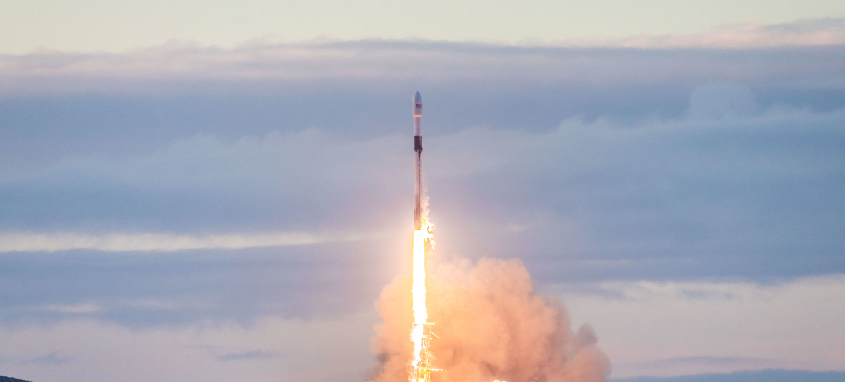](https://www.spacex.com/news/2019/01/11/iridium-8-mission)

JANUARY 11, 2019

## [IRIDIUM-8 MISSION](https://www.spacex.com/news/2019/01/11/iridium-8-mission)

On Friday, January 11 at 7:31 a.m. PST, 15:31 UTC, SpaceX successfully launched the eighth and final set of satellites in a series of 75 total satellites for Iridium’s next generation global satellite constellation, Iridium NEXT.

[READ ARTICLE](https://www.spacex.com/news/2019/01/11/iridium-8-mission)

[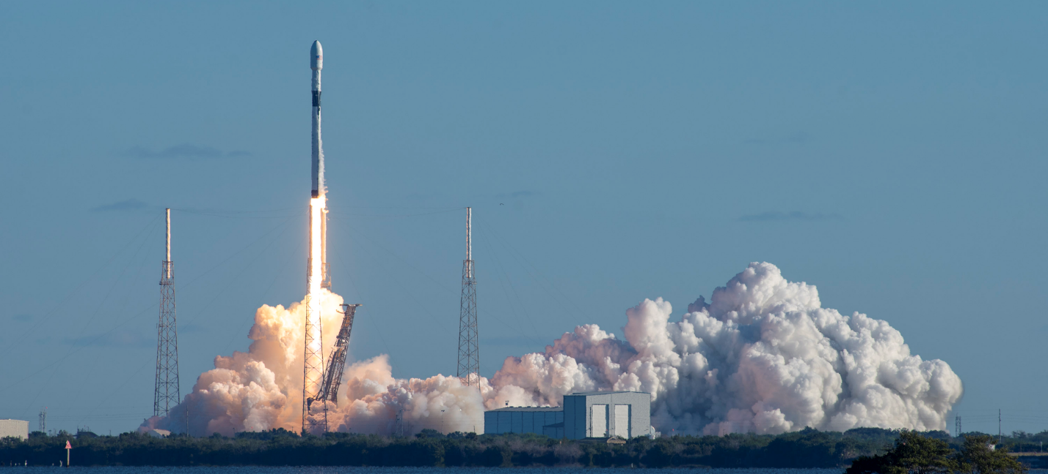](https://www.spacex.com/news/2018/12/23/gps-iii-space-vehicle-01-mission)

DECEMBER 23, 2018

## [GPS III SPACE VEHICLE 01 MISSION](https://www.spacex.com/news/2018/12/23/gps-iii-space-vehicle-01-mission)

On Sunday, December 23rd at 5:51 a.m. PST, SpaceX successfully launched the United States Air Force’s first Global Positioning System III space vehicle (SV) from Space Launch Complex 40 (SLC-40) at Cape Canaveral Air Force Station, Florida.

[READ ARTICLE](https://www.spacex.com/news/2018/12/23/gps-iii-space-vehicle-01-mission)

[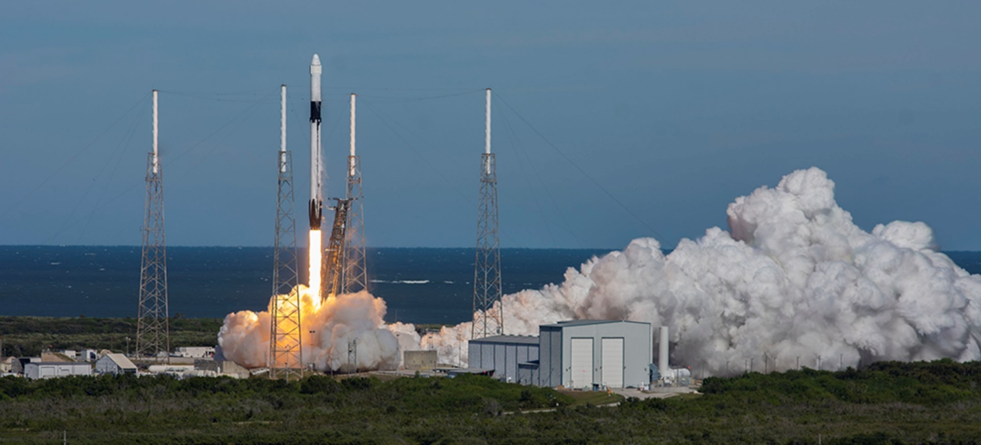](https://www.spacex.com/news/2018/12/05/dragon-resupply-mission-crs-16)

DECEMBER 05, 2018

## [DRAGON RESUPPLY MISSION (CRS-16)](https://www.spacex.com/news/2018/12/05/dragon-resupply-mission-crs-16)

On Wednesday, December 5, 2018, SpaceX launched its sixteenth Commercial Resupply Services mission (CRS-16) to the International Space Station. Liftoff occurred at 1:16 p.m.

[READ ARTICLE](https://www.spacex.com/news/2018/12/05/dragon-resupply-mission-crs-16)

[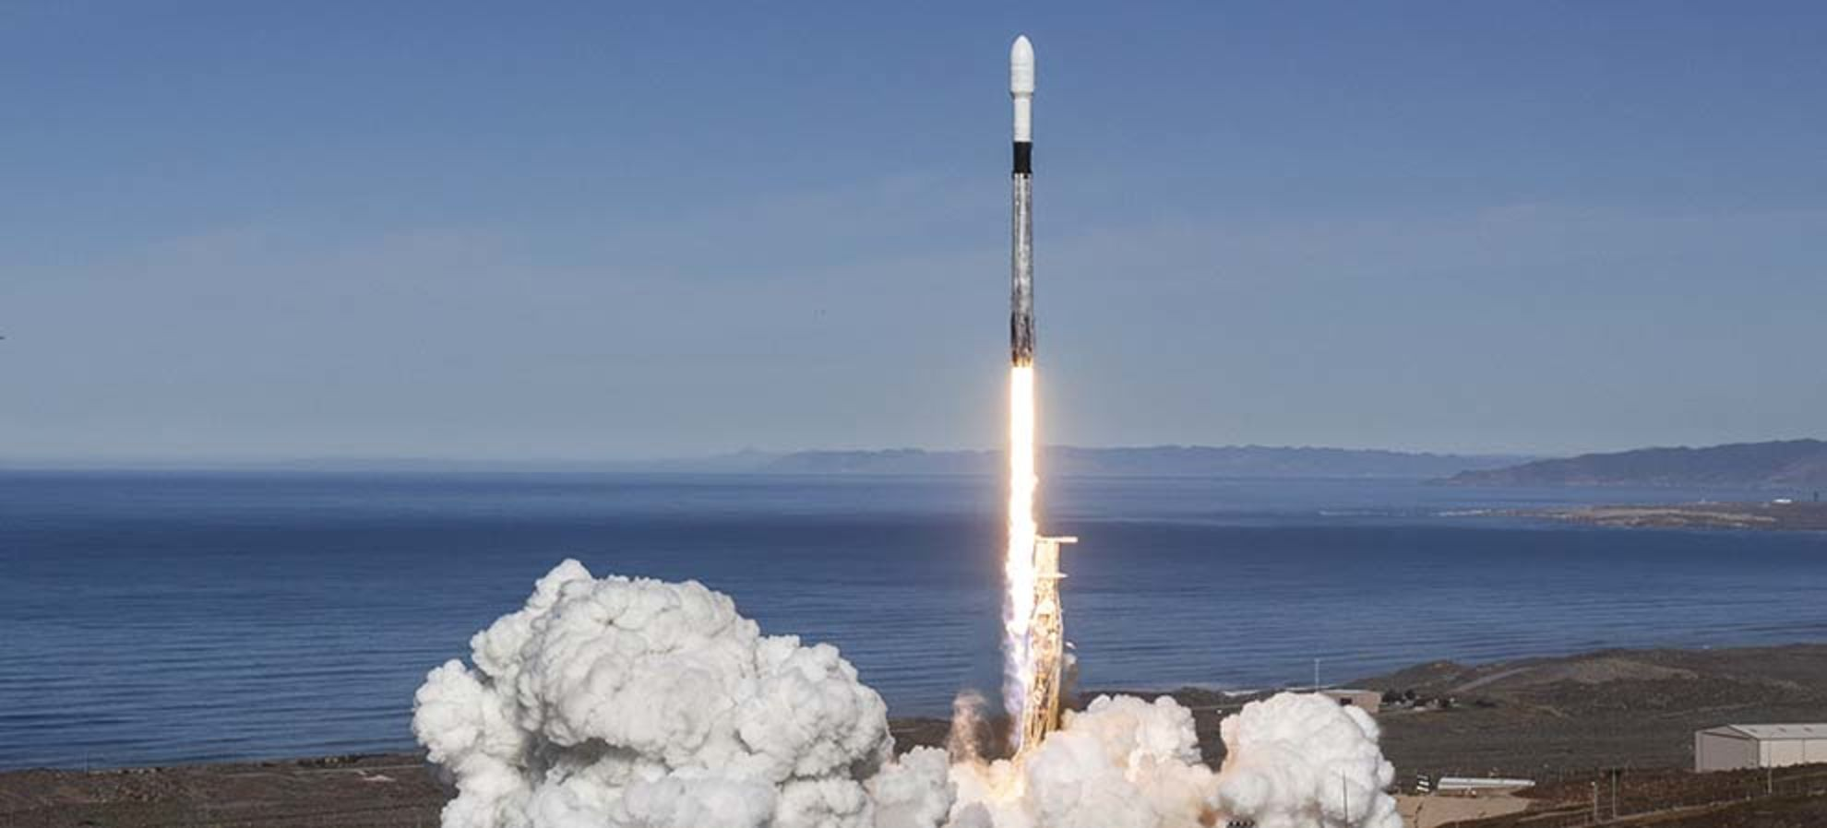](https://www.spacex.com/news/2018/12/03/spaceflight-sso-smallsat-express-mission)

DECEMBER 03, 2018

## [SPACEFLIGHT SSO-A: SMALLSAT EXPRESS MISSION](https://www.spacex.com/news/2018/12/03/spaceflight-sso-smallsat-express-mission)

On Monday, December 3rd at 10:34 a.m. PST, SpaceX successfully launched Spaceflight SSO-A: SmallSat Express to a low Earth orbit from Space Launch Complex 4E (SLC-4E) at Vandenberg Air Force Base, California.

[READ ARTICLE](https://www.spacex.com/news/2018/12/03/spaceflight-sso-smallsat-express-mission)

[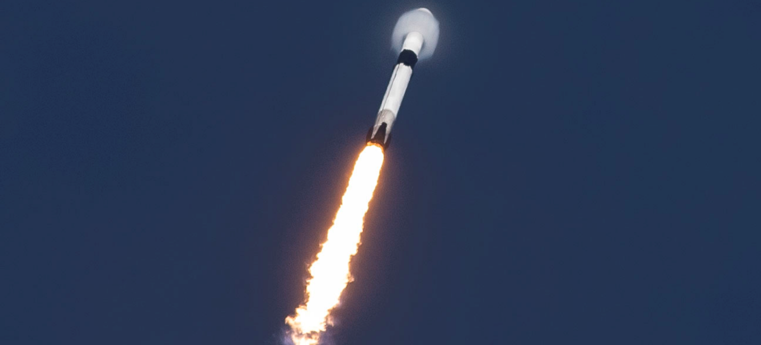](https://www.spacex.com/news/2018/11/15/eshail-2-mission)

NOVEMBER 15, 2018

## [ES'HAIL-2 MISSION](https://www.spacex.com/news/2018/11/15/eshail-2-mission)

SpaceX successfully launched the Es’hail-2 satellite on Thursday, November 15 from Launch Complex 39A (LC-39A) at NASA’s Kennedy Space Center in Florida. Liftoff occurred at 3:46 p.m.

[READ ARTICLE](https://www.spacex.com/news/2018/11/15/eshail-2-mission)

[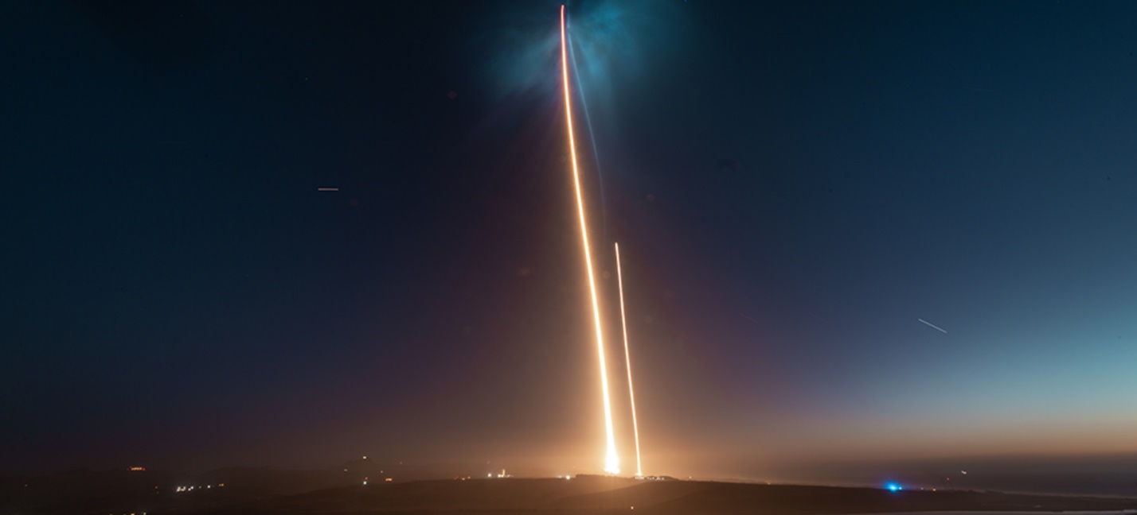](https://www.spacex.com/news/2018/10/07/saocom-1a-mission)

OCTOBER 07, 2018

## [SAOCOM 1A MISSION](https://www.spacex.com/news/2018/10/07/saocom-1a-mission)

On Sunday, October 7 at 7:21 p.m. PDT, SpaceX successfully launched the SAOCOM 1A satellite from Space Launch Complex 4E (SLC-4E) at Vandenberg Air Force Base in California. The satellite was deployed about 12 minutes after liftoff.

[READ ARTICLE](https://www.spacex.com/news/2018/10/07/saocom-1a-mission)

[](https://www.spacex.com/news/2018/10/09/first-passenger-lunar-bfr-mission)

SEPTEMBER 18, 2018

## [FIRST PASSENGER ON LUNAR BFR MISSION](https://www.spacex.com/news/2018/10/09/first-passenger-lunar-bfr-mission)

On September 17, 2018, SpaceX announced fashion innovator and globally recognized art curator Yusaku Maezawa will be the company’s first private passenger to fly around the Moon in 2023.

[READ ARTICLE](https://www.spacex.com/news/2018/10/09/first-passenger-lunar-bfr-mission)

[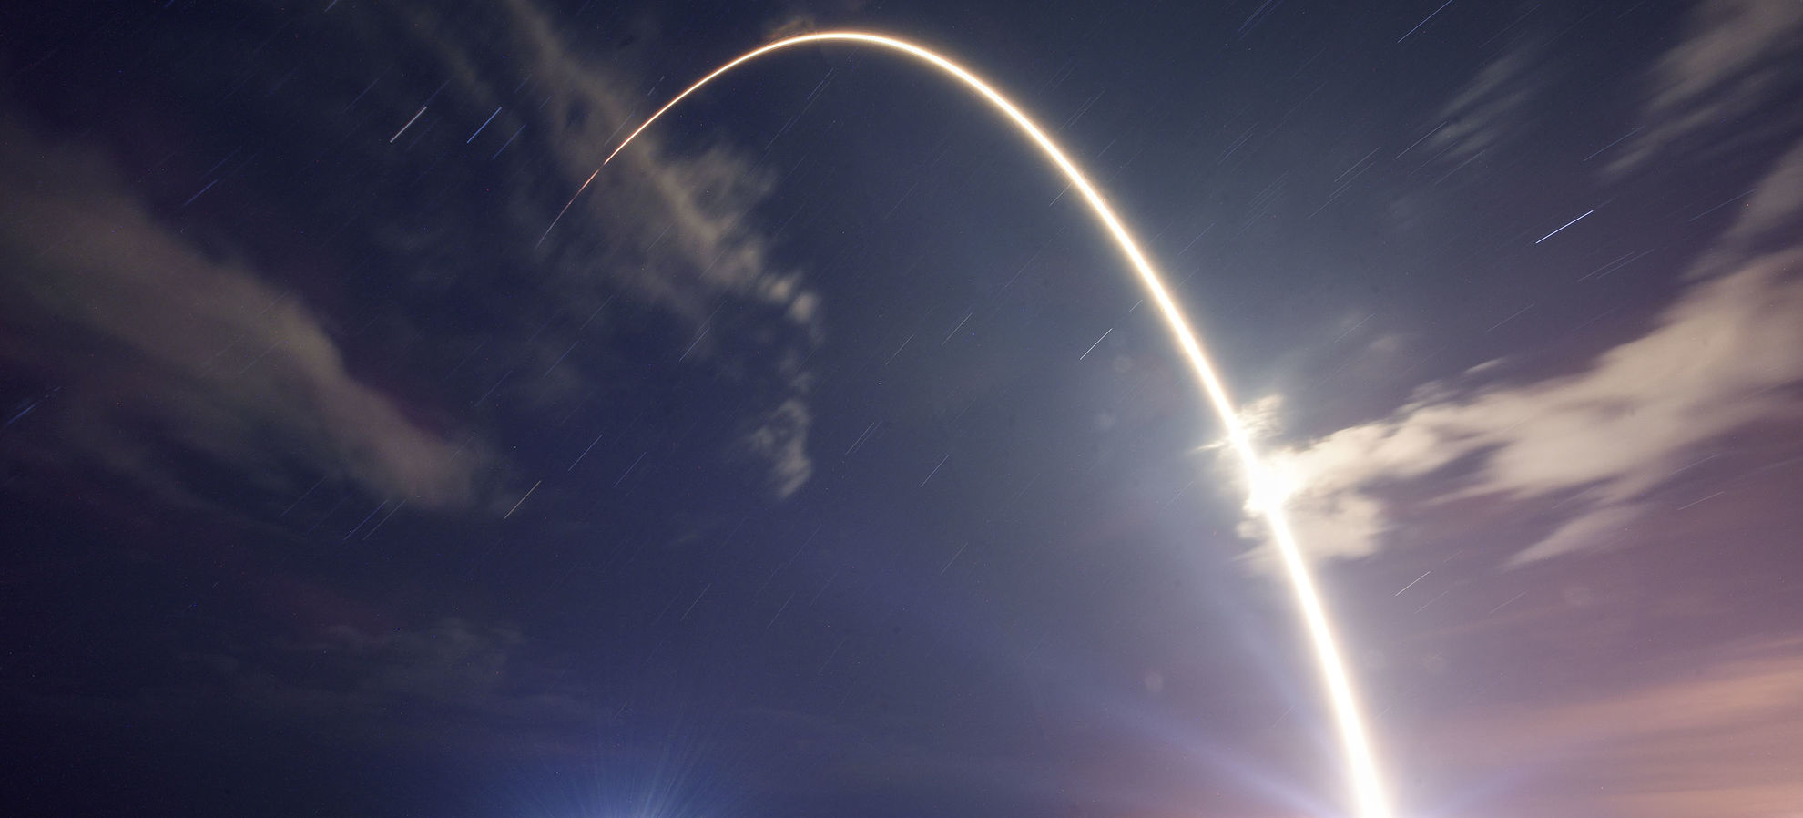](https://www.spacex.com/news/2018/09/09/telstar-18-vantage-mission)

SEPTEMBER 09, 2018

## [TELSTAR 18 VANTAGE MISSION](https://www.spacex.com/news/2018/09/09/telstar-18-vantage-mission)

On Monday, September 10th, SpaceX's Falcon 9 successfully lifted off at 12:45 a.m.

[READ ARTICLE](https://www.spacex.com/news/2018/09/09/telstar-18-vantage-mission)

[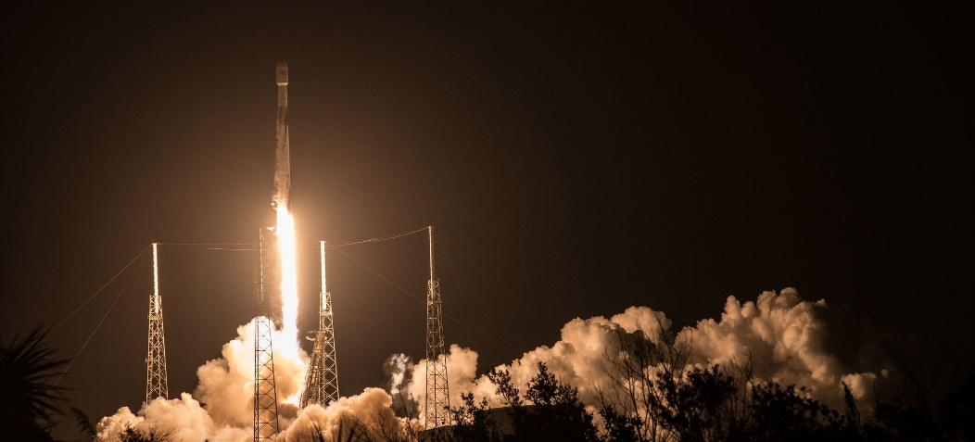](https://www.spacex.com/news/2018/08/06/merah-putih-mission)

AUGUST 06, 2018

## [MERAH PUTIH MISSION](https://www.spacex.com/news/2018/08/06/merah-putih-mission)

On Tuesday, August 7th at 1:18 a.m. EDT, Falcon 9 successfully lifted off from Space Launch Complex 40 (SLC-40) at Cape Canaveral Air Force Station, Florida carrying the Merah Putih mission for PT Telkom Indonesia.

[READ ARTICLE](https://www.spacex.com/news/2018/08/06/merah-putih-mission)

[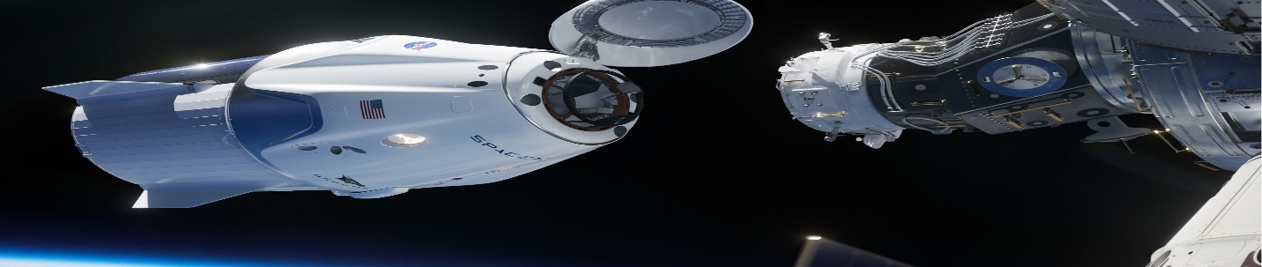](https://www.spacex.com/news/2018/08/04/nasa-astronauts-flying-aboard-crew-dragon)

AUGUST 04, 2018

## [NASA ASTRONAUTS FLYING ABOARD CREW DRAGON](https://www.spacex.com/news/2018/08/04/nasa-astronauts-flying-aboard-crew-dragon)

On Friday, August 3, 2018, NASA announced the first four astronauts who will launch aboard Crew Dragon (also known as Dragon 2) to the International Space Station as part of NASA’s [Commercial Crew P](https://blogs.nasa.gov/commercialcrew/)

[READ ARTICLE](https://www.spacex.com/news/2018/08/04/nasa-astronauts-flying-aboard-crew-dragon)

# ESA

# <https://www.esa.int/Our_Activities/Space_News>

[ESA](https://www.esa.int/) > [Our Activities](https://www.esa.int/Our_Activities) > Space News

## OUR MISSIONS

[All missions](https://www.esa.int/ESA/Our_Missions)

|  |  |  |
| --- | --- | --- |
| **NAME** | **LAUNCH** | **MISSION** |
| |  |  |  | | --- | --- | --- | | [EDRS](https://www.esa.int/Our_Activities/Telecommunications_Integrated_Applications/EDRS) | 2016 | Geostationary satellites for relaying satellite data |  |  |  |  | | --- | --- | --- | | [Exomars](http://exploration.esa.int/science-e/www/area/index.cfm?fareaid=118) | 2016 | Mars orbiter and lander, followed by rover and surface platform | | [SmallGEO](https://www.esa.int/Our_Activities/Telecommunications_Integrated_Applications/Small_Geostationary_Satellite_SGEO) | 2017 | New small platform for geostationary telecommunications | | | |

## LATEST NEWS



[Space weather kicks up a social storm](https://www.esa.int/Our_Activities/Operations/Space_Situational_Awareness/Space_weather_kicks_up_a_social_storm)01 March 2019

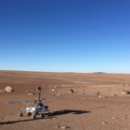

[Fit for Mars](https://www.esa.int/Our_Activities/Human_and_Robotic_Exploration/Exploration/ExoMars/Fit_for_Mars)28 February 2019

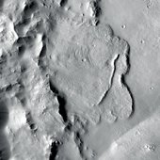

[First evidence of planet-wide groundwater system on Mars](https://www.esa.int/Our_Activities/Space_Science/Mars_Express/First_evidence_of_planet-wide_groundwater_system_on_Mars)28 February 2019

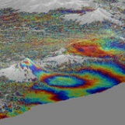

[Copernicus Sentinel-1 reveals shared plumbing led to Agung awakening](https://www.esa.int/Our_Activities/Observing_the_Earth/Copernicus/Sentinel-1/Copernicus_Sentinel-1_reveals_shared_plumbing_led_to_Agung_awakening)22 February 2019

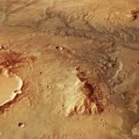

[Signs of ancient flowing water on Mars](https://www.esa.int/Our_Activities/Space_Science/Mars_Express/Signs_of_ancient_flowing_water_on_Mars2)21 February 2019

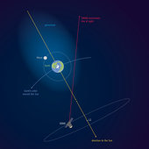

[Earth’s atmosphere stretches out to the Moon – and beyond](https://www.esa.int/Our_Activities/Space_Science/Earth_s_atmosphere_stretches_out_to_the_Moon_and_beyond)20 February 2019

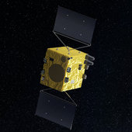

[Close encounters: planning for extra Hera flyby](https://www.esa.int/Our_Activities/Space_Engineering_Technology/Hera/Close_encounters_planning_for_extra_Hera_flyby)20 February 2019

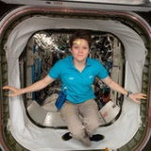

[Space behaviour](https://www.esa.int/Our_Activities/Human_and_Robotic_Exploration/International_Space_Station/Space_behaviour)19 February 2019

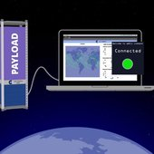

[Interactive space simulation for nanosatellites](https://www.esa.int/Our_Activities/Telecommunications_Integrated_Applications/Interactive_space_simulation_for_nanosatellites)19 February 2019

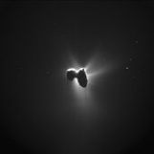

[Rosetta’s comet sculpted by stress](https://www.esa.int/Our_Activities/Space_Science/Rosetta/Rosetta_s_comet_sculpted_by_stress)18 February 2019



[Astronaut photography benefiting the planet](https://www.esa.int/Our_Activities/Human_and_Robotic_Exploration/Astronaut_photography_benefiting_the_planet)15 February 2019

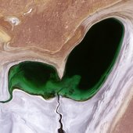

[Shrinking heart](https://www.esa.int/Our_Activities/Observing_the_Earth/Shrinking_heart)13 February 2019



[Shrinking heart](https://www.esa.int/Our_Activities/Observing_the_Earth/Shrinking_heart)13 February 2019 This heart-shaped body of water may look cute for Valentine’s Day but just as love sometimes fades, this emerald sea is withering away.

# ROSCOSMOS

* [March 02, 2019Roscosmos and NASA Work Out the Safety Protocols for Docking of American Spacecraft](http://en.roscosmos.ru/20770/)
* [February 19, 2019Roscosmos and Space Adventures signed a contract for the implementation of the short duration space flights to the ISS](http://en.roscosmos.ru/20769/)
* [February 13, 2019GK Activated Online Launch Price Calculator for SmallSats](http://en.roscosmos.ru/20768/)

# CHINA SPACE AGENCY

<http://www.cnsa.gov.cn/english/index.html>

|  |  |  |  |  |  |  |  |  |  |  |  |  |  |  |  |  |  |  |  |  |  |
| --- | --- | --- | --- | --- | --- | --- | --- | --- | --- | --- | --- | --- | --- | --- | --- | --- | --- | --- | --- | --- | --- |
| |  |  | | --- | --- | | [Xi meets Chang'e-4 mission representatives](http://www.cnsa.gov.cn/english/n6465652/n6465653/c6805507/content.html) | 02-21 |  |  |  | | --- | --- | | [China's Chang'e-4 probe wakes up after first lunar night](http://www.cnsa.gov.cn/english/n6465652/n6465653/c6805358/content.html) | 02-01 |  |  |  | | --- | --- | | [China open to int'l cooperation in future space missions](http://www.cnsa.gov.cn/english/n6465652/n6465653/c6805234/content.html) | 01-15 |  |  |  | | --- | --- | | [China declares Chang'e-4 mission complete success](http://www.cnsa.gov.cn/english/n6465652/n6465653/c6805233/content.html) | 01-15 |  |  |  | | --- | --- | | [China welcomes world's scientists to collaborate in lunar explorat...](http://www.cnsa.gov.cn/english/n6465652/n6465653/c6805232/content.html) | 01-15 |  |  |  | | --- | --- | | [Chang'e-4 probe takes panoramic photos on moon's far side](http://www.cnsa.gov.cn/english/n6465652/n6465653/c6805231/content.html) | 01-15 |  |  |  | | --- | --- | | [Breathtaking 12 minutes for Chang'e-4's landing](http://www.cnsa.gov.cn/english/n6465652/n6465653/c6805104/content.html) | 01-04 |  |  |  | | --- | --- | | [China names new moon rover "YuTu-2"](http://www.cnsa.gov.cn/english/n6465652/n6465653/c6805105/content.html) | 01-04 |  |  |  | | --- | --- | | [Chang'e-4 lands on largest crater in solar system](http://www.cnsa.gov.cn/english/n6465652/n6465653/c6805106/content.html) | 01-04 |  |  |  | | --- | --- | | [China's Chang'e-4 probe makes historic landing on moon's far side](http://www.cnsa.gov.cn/english/n6465652/n6465653/c6805049/content.html) | 01-03 |  |  | | --- | | 1 [2](javascript:pageName=35;goPub('../../n6465652/n6465653/index_6600691_35.html')) [3](javascript:pageName=34;goPub('../../n6465652/n6465653/index_6600691_34.html')) [4](javascript:pageName=33;goPub('../../n6465652/n6465653/index_6600691_33.html')) [5](javascript:pageName=32;goPub('../../n6465652/n6465653/index_6600691_32.html')) [6](javascript:pageName=31;goPub('../../n6465652/n6465653/index_6600691_31.html')) [7](javascript:pageName=30;goPub('../../n6465652/n6465653/index_6600691_30.html')) [8](javascript:pageName=29;goPub('../../n6465652/n6465653/index_6600691_29.html')) [9](javascript:pageName=28;goPub('../../n6465652/n6465653/index_6600691_28.html')) [10](javascript:pageName=27;goPub('../../n6465652/n6465653/index_6600691_27.html')) [下页](javascript:pageName=35;goPub('../../n6465652/n6465653/index_6600691_35.html')) [尾页](javascript:pageName=1;goPub('../../n6465652/n6465653/index_6600691_1.html')) 总页数:36 | |

## VIRGIN GALACTIC

## Virgin Galactic Makes Space for Second Time in Ten Weeks with Three On Board, Reaching Higher Altitudes and Faster Speeds, as Flight Test Program Continues

[Read more](https://www.virgingalactic.com/articles/virgin-galactic-makes-space-for-second-time-in-ten-weeks-with-three-on-board)

[[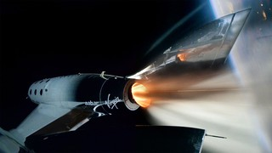](https://www.virgingalactic.com/articles/vss-unity-prepares-for-fifth-supersonicpowered-test-flight)](https://www.virgingalactic.com/articles/vss-unity-prepares-for-fifth-supersonicpowered-test-flight)

## SpaceShipTwo, VSS Unity, Prepares For Fifth Supersonic Powered Test Flight

[Read more](https://www.virgingalactic.com/articles/vss-unity-prepares-for-fifth-supersonicpowered-test-flight)

[[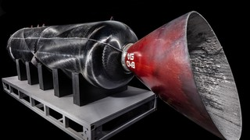](https://www.virgingalactic.com/articles/virgin-galactic-and-the-spaceship-company-donate-record-setting-rocket-motor)](https://www.virgingalactic.com/articles/virgin-galactic-and-the-spaceship-company-donate-record-setting-rocket-motor)

## Spaceflight Rocket Motor donated to the Smithsonian Air & Space Museum

[Read more](https://www.virgingalactic.com/articles/virgin-galactic-and-the-spaceship-company-donate-record-setting-rocket-motor)

## Virgin Galactic Pilots Awarded Commercial Astronaut Wings

[Read more](https://www.virgingalactic.com/articles/virgin-galactic-pilots-awarded-commercial-astronaut-wings)

## Virgin Galactic Unveils Under Armour As Exclusive Technical Spacewear Partner

[Read more](https://www.virgingalactic.com/articles/virgin-galactic-and-under-armour-announce-partnership)

[[](https://www.virgingalactic.com/articles/virgin-galactic-and-the-spaceship-company-donate-record-setting-rocket-motor)](https://www.virgingalactic.com/articles/virgin-galactic-and-the-spaceship-company-donate-record-setting-rocket-motor)

### FEBRUARY 7, 2019

## Spaceflight Rocket Motor donated to the Smithsonian Air & Space Museum

[Read more](https://www.virgingalactic.com/articles/virgin-galactic-and-the-spaceship-company-donate-record-setting-rocket-motor)

### JANUARY 24, 2019

## Virgin Galactic Unveils Under Armour As Exclusive Technical Spacewear Partner

[Read more](https://www.virgingalactic.com/articles/virgin-galactic-and-under-armour-announce-partnership)

[[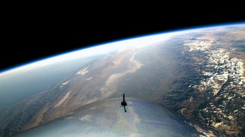](https://www.virgingalactic.com/articles/first-space-flight)](https://www.virgingalactic.com/articles/first-space-flight)

### DECEMBER 13, 2018

## Richard Branson Welcomes Astronauts Home from Virgin Galactic’s Historic First Spaceflight

[Read more](https://www.virgingalactic.com/articles/first-space-flight)

[[](https://www.virgingalactic.com/articles/Virgin-Galactic-Flight-Test-Program-Update-SpaceShipTwo-Preparing-For-Fourth-Powered-Test-Flight)](https://www.virgingalactic.com/articles/Virgin-Galactic-Flight-Test-Program-Update-SpaceShipTwo-Preparing-For-Fourth-Powered-Test-Flight)

### DECEMBER 12, 2018

## Virgin Galactic Flight Test Program Update - SpaceShipTwo Preparing For Fourth Powered Test Flight

[Read more](https://www.virgingalactic.com/articles/Virgin-Galactic-Flight-Test-Program-Update-SpaceShipTwo-Preparing-For-Fourth-Powered-Test-Flight)

[[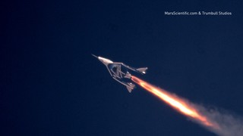](https://www.virgingalactic.com/articles/Into-the-Mesosphere-at-Mach-2)](https://www.virgingalactic.com/articles/Into-the-Mesosphere-at-Mach-2)

### JULY 26, 2018

## Into the Mesosphere at Mach 2.4

[Read more](https://www.virgingalactic.com/articles/Into-the-Mesosphere-at-Mach-2)

[[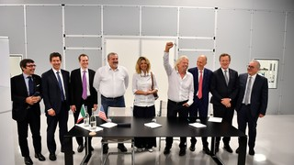](https://www.virgingalactic.com/articles/altec-sitael-virgingalactic-and-thespaceshipcompany-sign-framework-to-bring-commercial-spaceflights-to-italy)](https://www.virgingalactic.com/articles/altec-sitael-virgingalactic-and-thespaceshipcompany-sign-framework-to-bring-commercial-spaceflights-to-italy)

### JULY 6, 2018

## ALTEC, SITAEL, Virgin Galactic & The Spaceship Company Sign Framework to Bring Commercial Spaceflights to Italy

Press Release

[Read more](https://www.virgingalactic.com/articles/altec-sitael-virgingalactic-and-thespaceshipcompany-sign-framework-to-bring-commercial-spaceflights-to-italy)

[[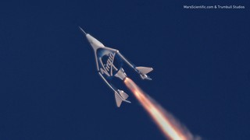](https://www.virgingalactic.com/articles/Richard-Branson-Welcomes-VSS-Unity-Home-from-Second-Supersonic-Flight)](https://www.virgingalactic.com/articles/Richard-Branson-Welcomes-VSS-Unity-Home-from-Second-Supersonic-Flight)

### MAY 29, 2018

## Richard Branson Welcomes VSS Unity Home from Second Supersonic Flight

[Read more](https://www.virgingalactic.com/articles/Richard-Branson-Welcomes-VSS-Unity-Home-from-Second-Supersonic-Flight)

[[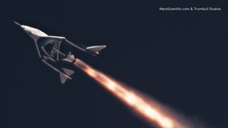](https://www.virgingalactic.com/articles/VSS-Unity-First-Powered-Flight)](https://www.virgingalactic.com/articles/VSS-Unity-First-Powered-Flight)

### APRIL 5, 2018

## VSS Unity First Powered Flight

A major step forward

[Read more](https://www.virgingalactic.com/articles/VSS-Unity-First-Powered-Flight)

[[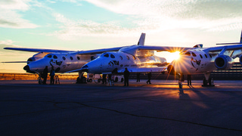](https://www.virgingalactic.com/articles/Update-From-Mojave-VSS-Unity-Successfully-Completes-High-Speed-Glide-Flight)](https://www.virgingalactic.com/articles/Update-From-Mojave-VSS-Unity-Successfully-Completes-High-Speed-Glide-Flight)

### JANUARY 11, 2018

## Update From Mojave: VSS Unity Successfully Completes High Speed Glide Flight

Unity successfully completed her seventh glide flight.

[Read more](https://www.virgingalactic.com/articles/Update-From-Mojave-VSS-Unity-Successfully-Completes-High-Speed-Glide-Flight)

[[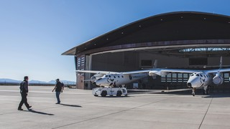](https://www.virgingalactic.com/articles/italian-space-agency)](https://www.virgingalactic.com/articles/italian-space-agency)

### DECEMBER 18, 2017

## Italian Space Agency (ASI) Signs Letter Of Intent For Virgin Galactic Research Flight

Press Release

[Read more](https://www.virgingalactic.com/articles/italian-space-agency)

[[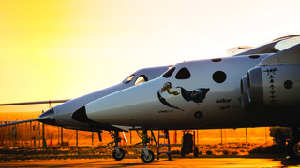](https://www.virgingalactic.com/articles/saudi-arabia-and-virgin-announce-partnership)](https://www.virgingalactic.com/articles/saudi-arabia-and-virgin-announce-partnership)

### OCTOBER 26, 2017

## Kingdom Of Saudi Arabia And Virgin Announce Partnership On Spaceflight, Satellite Launch And Space Centric Entertainment Industry

Press Release

[Read more](https://www.virgingalactic.com/articles/saudi-arabia-and-virgin-announce-partnership)

[[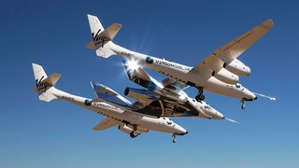](https://www.virgingalactic.com/articles/update-from-mojave-vss-unity-flies-with-propulsion-systems-installed-and-live)](https://www.virgingalactic.com/articles/update-from-mojave-vss-unity-flies-with-propulsion-systems-installed-and-live)

### AUGUST 4, 2017

## Update From Mojave: VSS Unity Flies With Propulsion Systems Installed And Live

This was Unity’s sixth glide test and essentially a dry run for rocket-powered flights.

[Read more](https://www.virgingalactic.com/articles/update-from-mojave-vss-unity-flies-with-propulsion-systems-installed-and-live)

https://www.virgingalactic.com/news/