July 2022 SPACE ECONOMY NEWS -Update Dr Jack Dyer, Blue Economy Future SA

Contents
December 2021 SPACE ECONOMY NEWS -Update Dr Jack Dyer, Blue Economy Future SA 1
NASA 4
NASA's Webb Telescope Launches to See First Galaxies, Distant Worlds 4
NASA Selects Four University Teams for Aviation Projects 4
NASA Awards Contract for Software Engineering Services at Goddard 4
NASA Awards Systems and Software Assurance Services 2 Contract 5
NASA’s 2021 Included Mars Landing, First Flight, Artemis, More 5
Detergent, Skin Bioprinter Launch on NASA’s SpaceX Resupply Mission 5
NASA Sets Coverage, Invites Public to View Webb Telescope Launch 5
NASA Awards Marshall Engineering Support Contract 5
Two Astronauts Receive Assignments for NASA’s SpaceX Crew-6 Mission 5
NASA Sets Coverage, Invites Public to Virtually Join Next Cargo Launch 6
NASA Awards Contracts for Rotorcraft Vertical Lift Technology Services 6
NASA Selects Second Private Astronaut Mission to Space Station 6
NASA Selects Education Projects to Help Broaden STEM Participation 6
NASA Launches New Mission to Explore Universe’s Most Dramatic Objects 6
NASA Invites Media to Briefing on Research Launching to Space Station 6
NASA Administrator Pays Tribute to Senior Advisor Mark Geyer 7
NASA’s Laser Communications Tech, Science Experiment Safely in Space 7
La NASA selecciona nuevos candidatos a astronauta 7
NASA Selects New Astronaut Recruits to Train for Future Missions 7
NASA to Highlight New Science Findings, Missions During AGU Meeting 7
Space News 7
News 8
SPACE.COM 8
Space News 8
NASA's James Webb Space Telescope mission: Live updates 8
'29 days on the edge:' What's next for NASA's newly launched James Webb Space Telescope 8
5 space missions to look forward to now that Webb has launched 8
On This Day in Space! Dec. 26, 1974: Salyut 4 space station launches into orbit 8
'Wind' from Earth's middle layer blows through a secret passage beneath Panama 9
Rare wispy ice formations streak across the sea near Antarctica in beautiful satellite images 9
James Webb Space Telescope notches crucial maneuver to set its path 9
'It's truly Christmas': James Webb Space Telescope's yuletide launch has NASA overjoyed 9
Space photos: The most amazing images this week! 10
The top space stories of the week! 10
NASA's James Webb Space Telescope launches on epic mission to study early universe 10
Christmas launch of NASA's James Webb Space Telescope has sparked some epic holiday memes 10
Astronauts on International Space Station send Christmas video message to Earth 11
How to watch NASA's James Webb Space Telescope launch online in several languages on Christmas Day 11
James Webb Space Telescope's rocket begins fueling up for launch 11
Here's the space weather forecast for NASA's James Webb Space Telescope launch 11
Pictures from space! Our image of the day 12
The Christmas night sky: A 2021 Yuletide stargazing guide 12
30 years and $10 billion later, the James Webb Space Telescope is finally on the launch pad 12
NASA's James Webb Space Telescope won't hit Santa during Christmas launch 12
Space News 13
BROWSE CATEGORIES 13
James Webb Space Telescope: The scientific mysteries no other observatory could unravel 13
Track Santa as he delivers gifts around the world on Christmas Day 13
Nerves run high ahead of the James Webb Space Telescope launch this Saturday 13
How a real NASA patch anchors Netflix's 'Don't Look Up' in reality 14
'Star Trek: Discovery' Season 4, Episode 6 keeps the tempo up 14
Comet Leonard shines amid aurora and meteor shower in stunning footage by Chinese spacecraft 14
This record-breaking black hole eruption could cover 16 full moons in the sky 14
Axiom Space developing in-house spacesuits to prepare for future stations 15
Watch an exclusive sneak peek at 'The Expanse' Season 6 Episode 3 (video) 15
When did scientists first warn humanity about climate change? 15
DeepMind cracks 'knot' conjecture that bedeviled mathematicians for decades 15
James Webb Space Telescope reaches launch pad for Christmas liftoff 16
SpaceX Dragon cargo ship delivers Christmas presents (and supplies) to space station 16
The James Webb Space Telescope will open up the 'secrets of the universe,' NASA administrator says 16
Why NASA's James Webb Space Telescope will orbit nearly 1 million miles from Earth 16
'The Book of Boba Fett,' new teasers offer a tantalizing glimpse of what to expect 17
NASA is tracking two explorers across Antarctica to prepare humans for Mars 17
Winner of Blue Origin's $28 million auction to fly with 5 'space warriors' next year 17
Daniel Abraham and Ty Franck on sticking the landing for final 'The Expanse' novel, 'Leviathan Falls' (exclusive) 17
Mars and Earth likely formed from collisions of moon-sized rocks 18
Space X 18
STARLINK MISSION 18
IMAGING X-RAY POLARIMETRY EXPLORER (IXPE) MISSION 19
DOUBLE ASTEROID REDIRECTION TEST (DART) MISSION 19
STARSHIP TO LAND NASA ASTRONAUTS ON THE MOON 19
ROSCOSMOS 20
EUROPEAN SPACE AGENCY 28
spotlight 28
webb: seeing farther 29
Liftoff in images: Webb on Ariane 5 30
Webb on Ariane 5 roll-out to the launch pad 30
Red velvet Mars 31
Webb on Ariane 5 poised for launch 31
Matthias’ international Christmas greetings 33
Webb on Ariane 5 roll-out to the launch pad 33
Webb launch date confirmed for 25 December 34
A Christmas comet for Solar Orbiter 34
MORE ITEMS 35
ESA highlights 2021 35
CHINA SPACE AGENCY 35
VIRGIN GALACTIC 36
Omaze and Virgin Galactic Announce Winner of Once-in-a-Lifetime Trip to Space 36
Virgin Galactic Announces Third Quarter 2021 Financial Results 36
Virgin Galactic Begins Planned Vehicle Enhancement and Modification Period; Unity 23 Test Flight Rescheduled to Follow Completion of This Program 36
SEPTEMBER 29, 2021 37
Virgin Galactic Cleared to Fly Following Conclusion of FAA Inquiry 37
SEPTEMBER 23, 2021 37
Virgin Galactic Hires Aparna Chitale as Chief People Officer 37
SEPTEMBER 23, 2021 38
Meet Aparna Chitale, Virgin Galactic’s Chief People Officer 38
SEPTEMBER 02, 2021 38
Virgin Galactic Announces First Commercial Research Mission 38
JULY 11, 2021 38
Virgin Galactic Successfully Completes First Fully Crewed Spaceflight 38
BLUE ORIGINS 39
Latest Updates 39

NASA

https://www.nasa.gov/news/releases/latest/index.html

NASA Awards Engineering, Technology, Science Contract
Jul 1, 2022 - NASA has awarded the JSC Engineering, Technology, and Science (JETS) II contract to Jacobs Technology Inc. of Tullahoma, Tennessee, to provide engineering and scientific products, technical services and related services for the agency’s Johnson Space Center in Houston, other NASA centers and government agencies.

Florida Students to Hear from NASA Astronauts Aboard Space Station
Jul 1, 2022 - Florida students will have an opportunity soon to hear from NASA astronauts aboard the International Space Station.

NASA Shares Climate, Earth Science Resources at Folklife Festival
Jun 30, 2022 - Members of the public are invited to explore the many ways space science helps families, communities, and our nation better understand our home planet and become more climate resilient through hands-on and virtual activities during NASA Day at the Smithsonian Folklife Festival Saturday, July 2, on the National Mall in Washington.

NASA to Industry: Let’s Develop Flight Tech to Reduce Carbon Emissions
Jun 30, 2022 - NASA announced Wednesday the agency is seeking partners to develop technologies needed to shape a new generation of lower-emission, single-aisle airliners that passengers could see in airports in the 2030s.

CAPSTONE Launches to Test New Orbit for NASA’s Artemis Moon Missions
Jun 28, 2022 - NASA’s CubeSat designed to test a unique lunar orbit is safely in space and on the first leg of its journey to the Moon.

NASA to Cover Northrop Grumman Cygnus Departure from Space Station
Jun 28, 2022 - Northrop Grumman’s uncrewed Cygnus spacecraft is scheduled to depart the International Space Station on Tuesday, June 28, more than four months after delivering 8,300 pounds of supplies, scientific investigations, commercial products, hardware, and other cargo to the orbiting laboratory for NASA.

NASA Awards Engineering Design, Inspection Services Contract
Jun 25, 2022 - NASA has awarded the Facilities Engineering Design and Inspection Services (FEDIS) II contract to Vanguard Pacific LLC of Foley, Alabama, to provide architect and engineering design services at the agency’s Marshall Space Flight Center in Huntsville, Alabama.

NASA Announces Launch Delay for Psyche Asteroid Mission
Jun 25, 2022 - NASA announced Friday that the Psyche asteroid mission – the agency’s first mission designed to study a metal-rich asteroid – will not make its planned 2022 launch attempt.

NASA to Discuss Psyche Asteroid Mission
Jun 25, 2022 - NASA will host a media teleconference at 2 p.m. EDT Friday to provide an update on the agency’s mission to study the Psyche asteroid. Audio of the briefing will livestream on the agency’s website.

NASA Sets Live Launch Coverage for CAPSTONE Mission to Moon
Jun 24, 2022 - NASA will air live launch coverage of the agency’s Cislunar Autonomous Positioning System Technology Operations and Navigation Experiment (CAPSTONE), the first spacecraft to fly a specific unique lunar orbit ahead of future missions with crew.

Space News

https://spacenews.com/
Agile to consolidate operations in new Colorado plant
by Debra Werner — July 1, 2022
Agile Space Industries is preparing to consolidate propulsion design, manufacturing and production in a new 1,860-square-meter facility in Durango, Colorado.

COMMERCIAL AGILE SPACE INDUSTRIESCOLORADOPROPULSION
OneWeb to launch second-generation satellites with Relativity Space
OneWeb to launch second-generation satellites with Relativity Space
by Jeff Foust — July 1, 2022
OneWeb will launch some of its next-generation satellites on Relativity Space’s next-generation launch vehicle starting as soon as 2025, the companies announced June 30.

COMMERCIAL LAUNCH ONEWEBRELATIVITY
Venus orbiter, lunar constellation and exoplanets telescopes among candidates as China selects new space science missions
Venus orbiter, lunar constellation and exoplanets telescopes among candidates as China selects new space science missions
by Andrew Jones — July 1, 2022
The Chinese Academy Sciences is preparing to select a new batch of space missions from proposals to study Earth, the Sun and solar system, and the deeper universe as part of a "New Horizons Program."

ASIA CHINACHINESE ACADEMY OF SCIENCESEARTH SCIENCEEXOPLANETSEXPLORATIONGRAVITATIONAL WAVESHELIOPHYSICSSPACE SCIENCEVENUS
House appropriators reduce proposed budget for FAA commercial space office
House appropriators reduce proposed budget for FAA commercial space office
by Jeff Foust — June 30, 2022
House appropriators eliminated most of a proposed budget increase for the FAA’s commercial space transportation office while also directing the agency on spaceports and cooperation with another agency on spaceflight investigations.

POLICY & POLITICS COMMERCIAL SPACE LAUNCHFAA OFFICE OF COMMERCIAL SPACE TRANSPORTATIONHOUSENTSBSPACEPORTS
Kepler books orbital transfer vehicle for next launch
Kepler books orbital transfer vehicle for next launch
by Jason Rainbow — June 30, 2022
Canada’s Kepler Communications said June 30 it plans to use D-Orbit’s orbital transfer vehicle for the next two satellites in its low-data-rate constellation.

COMMERCIAL LAUNCH D-ORBITKEPLER COMMUNICATIONS
China looks to launch liquid propellant rockets from the seas
China looks to launch liquid propellant rockets from the seas
by Andrew Jones — June 30, 2022
Chinese state-owned and commercial companies are developing capabilities to launch liquid propellant rockets from sea platforms to boost the country's launch options.

ASIA CALTCHINAGALACTIC ENERGYLONG MARCH 11LONG MARCH 8ORIENSPACE
NASA prepares to release first JWST science images
NASA prepares to release first JWST science images
by Jeff Foust — June 29, 2022
With commissioning of the James Webb Space Telescope nearly complete, project officials and NASA leadership promise the telescope’s first images will stun scientists and the public alike.

CIVIL JWSTNASA
SpaceX launches SES-22 C-band replacement satellite
SpaceX launches SES-22 C-band replacement satellite
by Jason Rainbow — June 29, 2022
SpaceX launched the first television broadcast satellite under SES’s C-band clearing plan June 29 from Cape Canaveral in Florida.

COMMERCIAL LAUNCH SESSPACEX
NASA administrator tests positive for COVID
NASA administrator tests positive for COVID
by Jeff Foust — June 29, 2022
NASA Administrator Bill Nelson has tested positive for COVID-19, he announced June 29, but is continuing to lead the agency as he isolates at home.

CIVIL BILL NELSONCOVID-19NASA
Space Force considering strategy for procuring national security launch services
Space Force considering strategy for procuring national security launch services
by Sandra Erwin — June 29, 2022
Space Force acquisition executive Frank Calvelli said he would be open to a different model than the current two-vendor approach for national security launch services procurement

LAUNCH MILITARY LAUNCH SERVICE PROCUREMENTNSSLSPACE FORCE
Avio gets pandemic recovery funds to develop launchers for the 2030s
Avio gets pandemic recovery funds to develop launchers for the 2030s
by Jason Rainbow — June 29, 2022
Italian rocket maker Avio secured 340 million euros ($358 million) in government funding June 29 to develop launch vehicles for the next decade.

EUROPE ARIANESPACEAVIO
Sierra Space signs agreement with Turkish Space Agency
Sierra Space signs agreement with Turkish Space Agency
by Jeff Foust — June 29, 2022
Sierra Space announced an agreement with the Turkish Space Agency and an affiliated company June 29 that could lead to cooperation on human spaceflight and lunar missions.

CIVIL COMMERCIAL SIERRA SPACETURKISH SPACE AGENCY
Rocket Lab sees payoff from CAPSTONE launch
Rocket Lab sees payoff from CAPSTONE launch
by Jeff Foust — June 28, 2022
The successful launch of a NASA lunar cubesat mission was the culmination of two and a half years of work at Rocket Lab that, the company’s chief executive says, could enable “ridiculously low cost” planetary missions.

COMMERCIAL LAUNCH CAPSTONEELECTRONROCKET LAB
Space Force acquisition chief to meet with ULA and Blue Origin, expects Vulcan to launch in December
Space Force acquisition chief to meet with ULA and Blue Origin, expects Vulcan to launch in December
by Sandra Erwin — June 28, 2022
Frank Calvelli said he wants to make sure Blue Origin and ULA understand 'the importance of hitting their milestones' for the BE-4 and Vulcan

LAUNCH MILITARY BLUE ORIGINSPACE FORCEULA
Virgin Orbit ready for first night launch
Virgin Orbit ready for first night launch
by Jeff Foust — June 28, 2022
Virgin Orbit says it’s ready for a nighttime launch for the U.S. Space Force as it attempts to get into a more frequent rhythm of building and launching vehicles.

COMMERCIAL LAUNCH MILITARY LAUNCHERONEVIRGIN ORBIT
Ovzon needs to piggyback another Ariane 5 ride for late 2022 launch
Ovzon needs to piggyback another Ariane 5 ride for late 2022 launch
by Jason Rainbow — June 28, 2022
Arianespace is looking to move Ovzon’s first satellite to another Ariane 5 after Eutelsat switched to a dedicated mission to launch sooner.

News

SPACE.COM

Space is supported by its audience. When you purchase through links on our site, we may earn an affiliate commission. Here’s why you can trust us

Space News

BROWSE CATEGORIES
- Infographics
- Countdowns
- References
- Quizzes
- Wallpapers

Exclusive: The hunter becomes the hunted in Marvel Comics 'Predator #1' relaunch
By Jeff Spry published about 1 hour ago
Marvel Comics releases its long-awaited "Predator" series from Ed Brisson and Kev Walker.

NASA's tiny CAPSTONE probe continues spiraling out toward the moon
By Mike Wall published about 2 hours ago
NASA's little CAPSTONE cubesat is making good progress on its long journey to the moon.

China launches new Gaofen 12 Earth observation satellite
By Andrew Jones published about 2 hours ago
China has launched another in its series of Gaofen Earth observation satellites as it continues building out its space infrastructure.

Astronauts may need to jump in space to fight bone loss
By Brett Tingley published about 3 hours ago
A new study suggests that high-impact exercise could help astronauts limit bone loss while in space.

Satellites watch record-breaking wildfires burn across Alaska
By Samantha Mathewson published about 5 hours ago
A hot, dry start to summer has spurred a record number of wildfires in southern Alaska, and weather satellites are tracking the development of the blazes from space.

Tricky Mars rocks making things difficult for NASA's Perseverance rover
By Samantha Mathewson published about 5 hours ago
NASA's Perseverance rover is on the hunt for the "goldilocks" of rocks to sample on Mars.

Surprise 'fossil galaxy' spotted near mighty Andromeda
By Elizabeth Howell published about 6 hours ago
An amateur astronomer found a fossilized surprise in the well-studied sky near the bright Andromeda Galaxy.

James Webb Space Telescope's supercold camera is now ready for science
By Tereza Pultarova published about 7 hours ago
The second of the four cutting-edge instruments on the James Webb Space Telescope is ready to perform science ahead of the awaited release of first full-quality images on July 12.

NASA will unveil the James Webb Space Telescope's 1st science photos this month. Here's how to watch.
By Elizabeth Howell published about 8 hours ago
After half a year of commissioning in space, the James Webb Space Telescope will release its first science images in July. Here's how you can tune in to the historic event for free.

SpaceX's Starlink satellites will help improve space weather forecasts amid sun's unpredictable activity
By Tereza Pultarova published about 10 hours ago
SpaceX's Starlink satellites are providing data to NOAA to help improve space weather forecasts as spacecraft operators struggle with unexpected effects of frequent solar eruptions.

Another supermoon rises this month with July's 'Buck Moon'
By Elizabeth Howell published about 10 hours ago
July's full moon will once again be a supermoon, reaching its perigee or closest point to our planet on July 13.

Where will NASA set up its moon base?
By Leonard David published about 10 hours ago
Artemis Base Camp will be established in the moon's south polar region, in a to-be-determined spot that features plentiful sunlight, direct-to-Earth communications and good access to water ice.

A huge comet will make its closest approach to Earth in July. Here's how to watch it live.
By Samantha Mathewson published about 10 hours ago
One of the farthest active comets ever spotted will make its closest approach to Earth on July 14, and here's how you can catch the action live.

On This Day In Space: July 1, 1962: Kennedy Space Center established
By Hanneke Weitering published about 10 hours ago
On July 1, 1962, NASA established the Launch Operations Center — which was later renamed the Kennedy Space Center — on the east coast of Florida.

Pictures from space! Our image of the day
By Space.com Staff published about 11 hours ago
An experimental moon exploration robot called Scout is being tested in the moon-like terrain of Italy's Etna volcano.

US Space Force establishes new unit to track 'threats in orbit'
By Brett Tingley published about 23 hours ago
The United States Space Force has activated a new unit that is tasked with providing "critical intelligence on threat systems, foreign intentions and activities in the space domain."

Watch NASA roll huge Artemis 1 moon rocket off the pad Friday
By Mike Wall published 1 day ago
NASA plans to start rolling its Artemis 1 moon mission off the launch pad Friday evening (July 1), and you can watch the slow-moving action live.

Satellite snaps gorgeous 4K selfie over Great Barrier Reef (video)
By Elizabeth Howell published 1 day ago
A new spacecraft selfie shows the machine in glorious 4K resolution above Australia's Great Barrier Reef.

'E.T. the Extra-Terrestrial' at 40: Spielberg’s charming sci-fi classic still offers wonder today
By Jeff Spry published 1 day ago
40 years ago director Steven Spielberg introduced audiences to a benevolent alien in "E.T" the Extra-Terrestrial

NASA's James Webb Space Telescope mission: Live updates
By Space.com Staff published 1 day ago
Read the latest news about NASA's James Webb Space Telescope.

Space X

https://www.spacex.com/news
INSTAGRAM FLICKR LINKEDIN PRIVACY POLICY

ROSCOSMOS

Russia publishes Pentagon coordinates, says Western ...
Dmitry Rogozin, head of Roscosmos, told the Russian RIA Novosti news agency: "The entire conglomerate of private and state orbital groupings...
.
2 days ago

The Jerusalem Post
Russian space agency Roscosmos shares images of NATO summit location
According to Roscosmos Director General Dmitry Rogozin, private Western satellite firms are sending information for NATO and, consequently, to...
.
3 days ago

Republic World
Roscosmos hacked after posting satellite images of NATO members' facilities: Report
Dmitry Strugovets, spokesperson of Roscosmos said as per Russian news agency TASS that the images featured the "decision-making centers" of...
.
2 days ago

Reuters
European Space Agency, Russia's Roscosmos hold talks on ...
Dmitry Rogozin, the head of Roscosmos, told the Russian TASS news agency over the weekend that the ESA would consult its members following the...
.
2 weeks ago

The Jerusalem Post
Cyberattack hits Russian space agency site after sharing NATO photos
The site of Russian space agency Roscosmos was targeted by hackers in a DDoS attack after it published satellite images of NATO buildings.
.
2 days ago

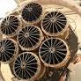
DW
Russia plans to restart German telescope without permission
Roscosmos will make relevant decisions in the near future," Rogozin said. ... The Russian Interfax news agency also cited him as saying that...
.
4 weeks ago

CGTN
U.S. paid 2 bln in rubles for astronaut's trip via Russian ...
Dmitry Rogozin, head of the Russia's state space corporation Roscosmos, ... spacecraft in an interview with the Russia 24 news channel.
.
3 weeks ago

Republic World
Roscosmos' only female cosmonaut to launch in SpaceX capsule on September 1: Report
Roscosmos' Anna Kikina will board SpaceX's Crew Dragon capsule on ... for September 1", Roscosmos said as per Russian news agency, TASS.
.
5 days ago

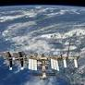
TDPel Media
Roscosmos State Corporation publishes images of Western decision-making centers
Roscosmos State Corporation publishes images of Western decision-making centers · See Something Say Something, Share The News · ↯↯↯Read More On...
.
3 days ago

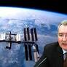
Republic World
Russia will work aboard International Space Station till 2024: Roscosmos chief Rogozin
Our minds are already living in that future", Rogozin said as per Russian news agency TASS. READ | Roscosmos to report its position on ISS...
.
4 weeks ago

EUROPEAN SPACE AGENCY

spotlight
SCIENCE & EXPLORATION

Media advisory: Webb telescope’s first images
NASA, ESA and CSA will release the James Webb Space Telescope’s first full-color images and spectroscopic data during a televised broadcast beginning at 16:30 CEST on Tuesday, 12 July.
21/06/20221039 VIEWS
OPEN

PRESS RELEASEN° 31–2022
SCIENCE & EXPLORATION

Call for Media: ARCHES robotic demonstration of Mount Etna in Sicily
Media representatives are invited to join the ARCHES Space-Analog Demonstration on Mount Etna in Sicily on 29 June 2022, to learn more about this test campaign of autonomous and interconnected robotic systems, designed for future lunar exploration and beyond. The campaign includes ESA testing of an advanced control system allowing astronauts in orbit to experience a ground-based rover’s sense of touch.
20/06/2022327 VIEWS
OPEN

PRESS RELEASEN° 30–2022
AGENCY

From the Earth to the Moon and on to Mars – ESA and NASA take decisions and plan for the future
The next steps in exploring and using space for the benefit of European citizens were this week on the agenda at ESA’s Council meeting in ESA/ESTEC, the Netherlands on 14 and 15 June. The possibility of the first-ever European astronaut to set foot on the Moon, a telecommunication satellite for lunar exploration and a mission to return precious rock samples from Mars were all discussed.
15/06/20224044 VIEWS
OPEN

PRESS RELEASEN° 29–2022
AGENCY

Invitation to the media: ILA Berlin
The media are cordially invited to attend a press conference with ESA Director General, Dr Josef Aschbacher, at ILA Berlin on Wednesday 22 June 2022 from 09:00–10:00 CEST.
15/06/2022224 VIEWS
OPEN

PRESS RELEASEN° 28–2022
SCIENCE & EXPLORATION

Gaia sees strange stars in most detailed Milky Way survey to date
Today, ESA’s Gaia mission released its new treasure trove of data about our home galaxy. Astronomers describe strange ‘starquakes’, stellar DNA, asymmetric motions and other fascinating insights in this most detailed Milky Way survey to date.Gaia is ESA’s mission to create the most accurate and complete multi-dimensional map of the Milky Way. This allows astronomers to reconstruct our home galaxy’s structure and past evolution over billions of years, and to better understand the lifecycle of stars and our place in the Universe.
13/06/2022739 VIEWS
OPEN

PRESS RELEASE ARCHIVE

Latest
ALL STORIES VIDEOS IMAGES

VIDEO00:40:12

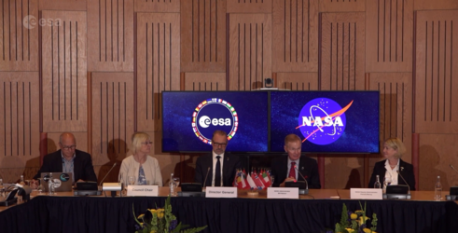AGENCY

Replay: NASA Administrator at the ESA Council
15/06/2022257 VIEWS3 LIKES
PLAY

VIDEO00:54:56

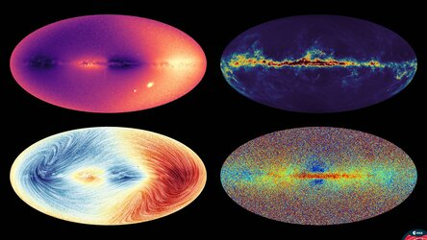SCIENCE & EXPLORATION

Gaia data release 3 – press event
13/06/20223833 VIEWS109 LIKES
PLAY

VIDEO00:57:08

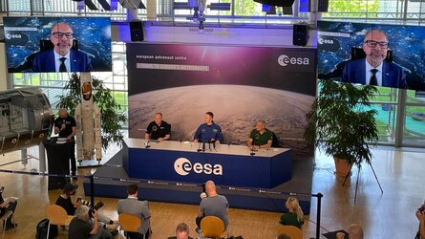SCIENCE & EXPLORATION

News Conference with ESA Astronaut Matthias Maurer (in Germ…
11/05/20221440 VIEWS45 LIKES
PLAY

STORY
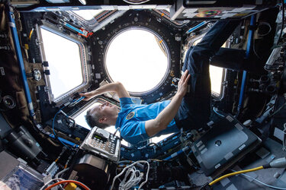SCIENCE & EXPLORATION

Watch live – Matthias Maurer returns to Earth
04/05/20225788 VIEWS44 LIKES
READ

VIDEO00:21:27

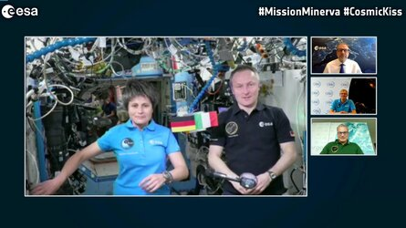SCIENCE & EXPLORATION

Inflight call with Samantha and Matthias
02/05/20225205 VIEWS62 LIKES
PLAY

VIDEO01:15:00

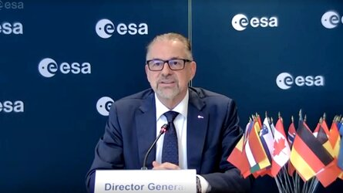AGENCY

Media session - ESA Council extraordinary meeting
13/04/20221327 VIEWS30 LIKES
PLAY

FOCUS ON

NASA to Host Briefings, Interviews for Agency’s SpaceX Crew…
OPEN

STORY
APPLICATIONS

Methane detected over Poland’s coal mines

22/12/20211654 VIEWS50 LIKES
PLAY

CHINA SPACE AGENCY

http://www.cnsa.gov.cn/english/index.html
Service Rules for the CHASE Satellite Data [06-23]

BRICS countries launch joint committee on space cooperation [05-26]

New cargo spacecraft being built [05-20]

China launches three low-orbit communication test satellites [05-20]

Tianwen-1 mission marks 1st year on Mars [05-16]

China's cargo craft docks with space station combination [05-11]

China launches atmospheric environment monitoring satellite [04-21]

■ Policies and Announcement more  China's Space Program: A 2021 Perspectiv...  International Lunar Research Station (IL...  Notice of China National Space Administr...  Announcement of Opportunities for Scient...  Announcement of Opportunities for Scient...  The introduction of RHU in Chang'e-4 mis...  China’s Space Activities in 2016 | ■ Intergovernmental Cooperation more  BRICS countries launch joint committee o...  CNSA: Promoting the building of a commun...  International Cooperation in outer space...  Russian-Chinese Joint Seminar on Coopera...  JOINT STATEMENT Between CNSA And ROSCOSM...  China, Russia welcome int'l partners in ...  CNSA and NASA held discussions on exchan... | ■ Major Project more  Chinese Mars mission sends photos of the...  Zhang Rongqiao: Mars explorer  Trekking 100 days on Mars, Zhurong drive...  Mars rover continues scientific mission  China's Tianwen-1 probe sends back Mars ...  Tianwen-1 probe will land on Mars in nex...  Tianwen 1 probe enters preset parking or...

■ Space Products

– Fengyun (FY) Meteoro...  – TianQin-1 Technology...  – Insight Hard X-ray M...  – Quantum Science Expe...  – SJ-10 Recoverable Sc...  Satellites more | – Space Laboratory Mis...  – Shenzhou X  – Shenzhou IX  – Shenzhou VIII  – Tiangong I  Spacecraft more | – Launch Vehicles  – Long March-5  – Long March-4B  – Long March-4A  – Long March-3C  Launch Vehicles

VIRGIN GALACTIC

https://www.virgingalactic.com/news/

Omaze and Virgin Galactic Announce Winner of Once-in-a-Lifetime Trip to Space
Read more
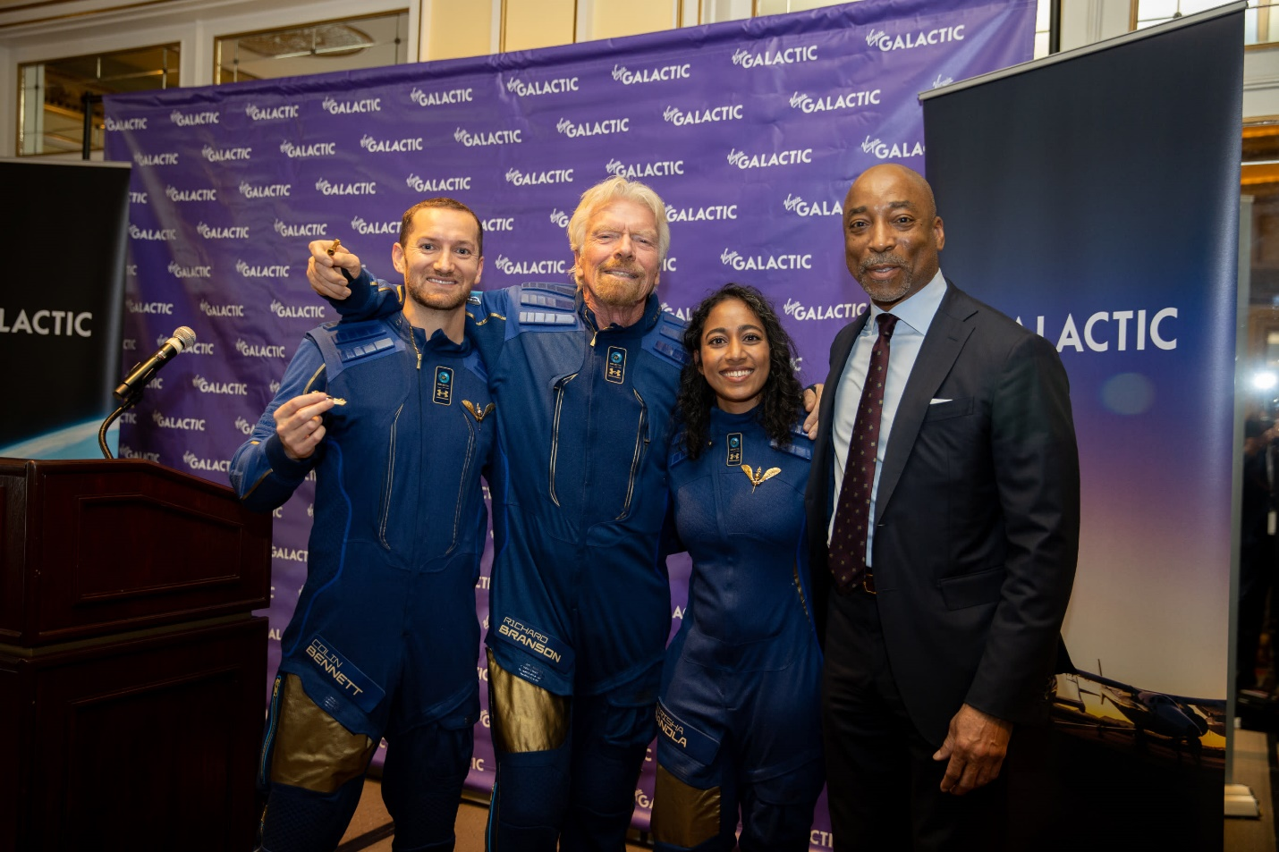
06.04.2022

37th Annual Space Symposium – Michael Colglazier Reflections Blog
Read more
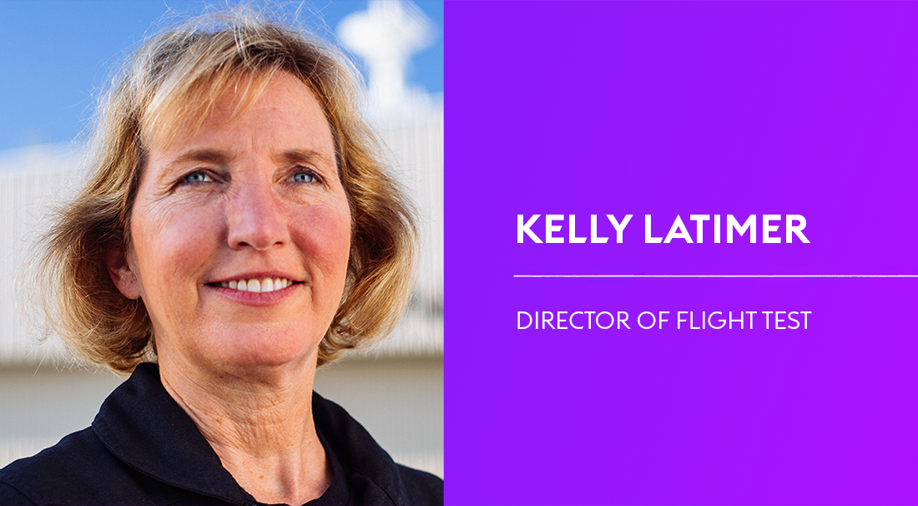
30.03.2022

Virgin Galactic Appoints Pilot Kelly Latimer to Director of Flight Test
Read more
28.02.2022

Land Rover Teams Up With Virgin Galactic For Sweepstakes To Send A Land Rover Vehicle Owner To Space
Read more
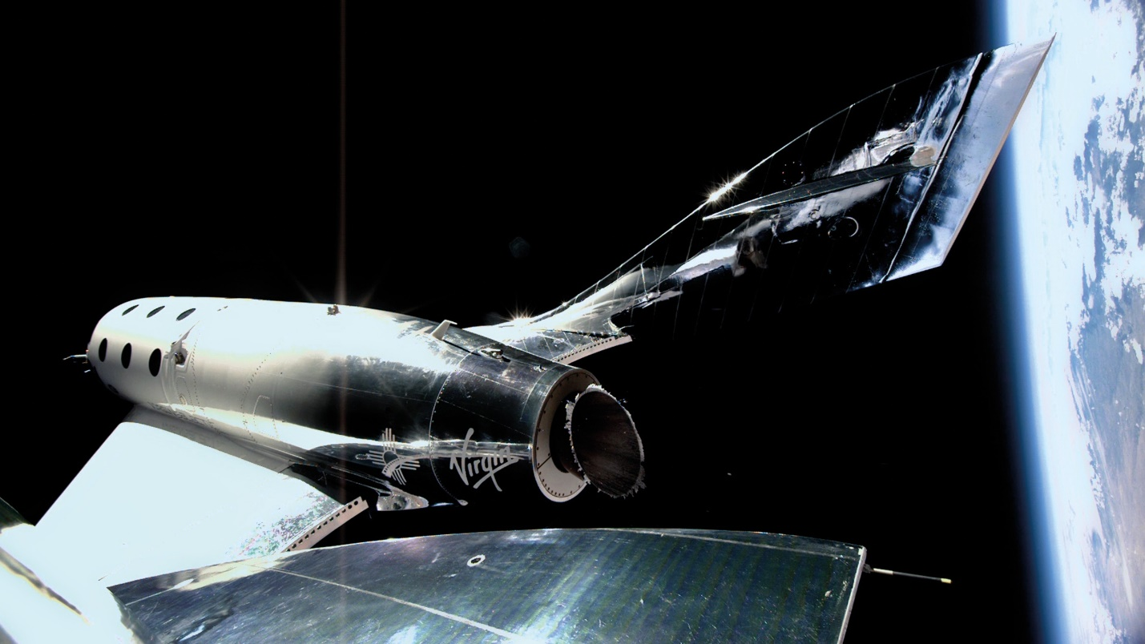
22.02.2022

Virgin Galactic Announces Fourth Quarter and Full Year 2021 Financial Results
Read more
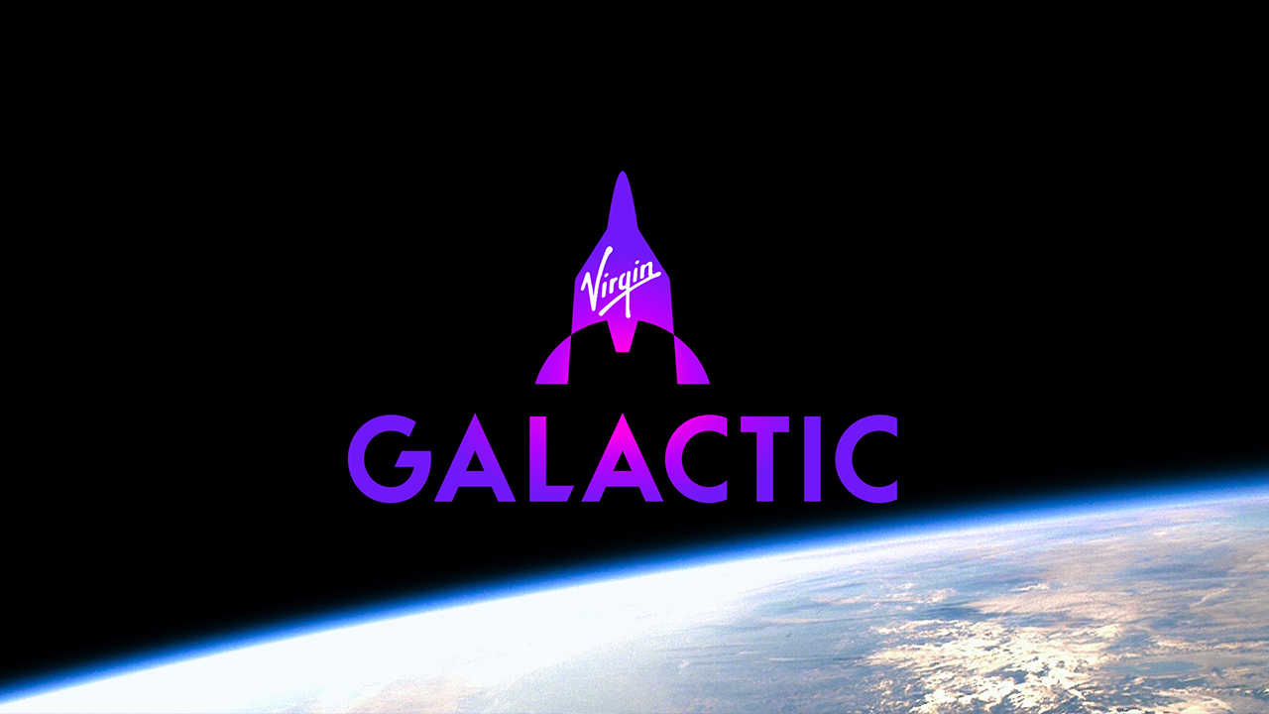
15.02.2022

Virgin Galactic Launches Spaceflight Reservations & New Consumer Brand

BLUE ORIGINS

Latest Updates
NEWS

General Hyten Joins Blue Origin as Executive Director of Club for the Future and Strategic Advisor
Blue Origin today announced that General John Hyten (Ret.) will serve as executive director for its foundation, Club for

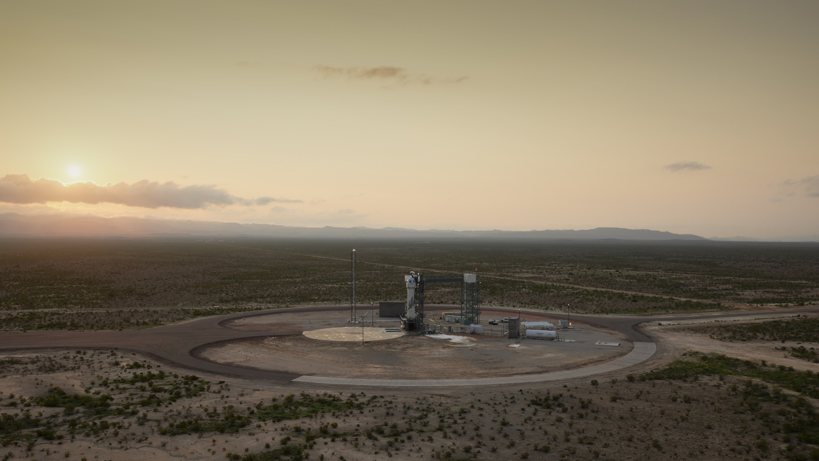
JUN 4, 2022
NEWS

Blue Origin Successfully Completes 21st Mission
Mission NS-21 is New Shepard’s Fifth Crewed Flight Today, Blue Origin successfully completed its fifth human spaceflight

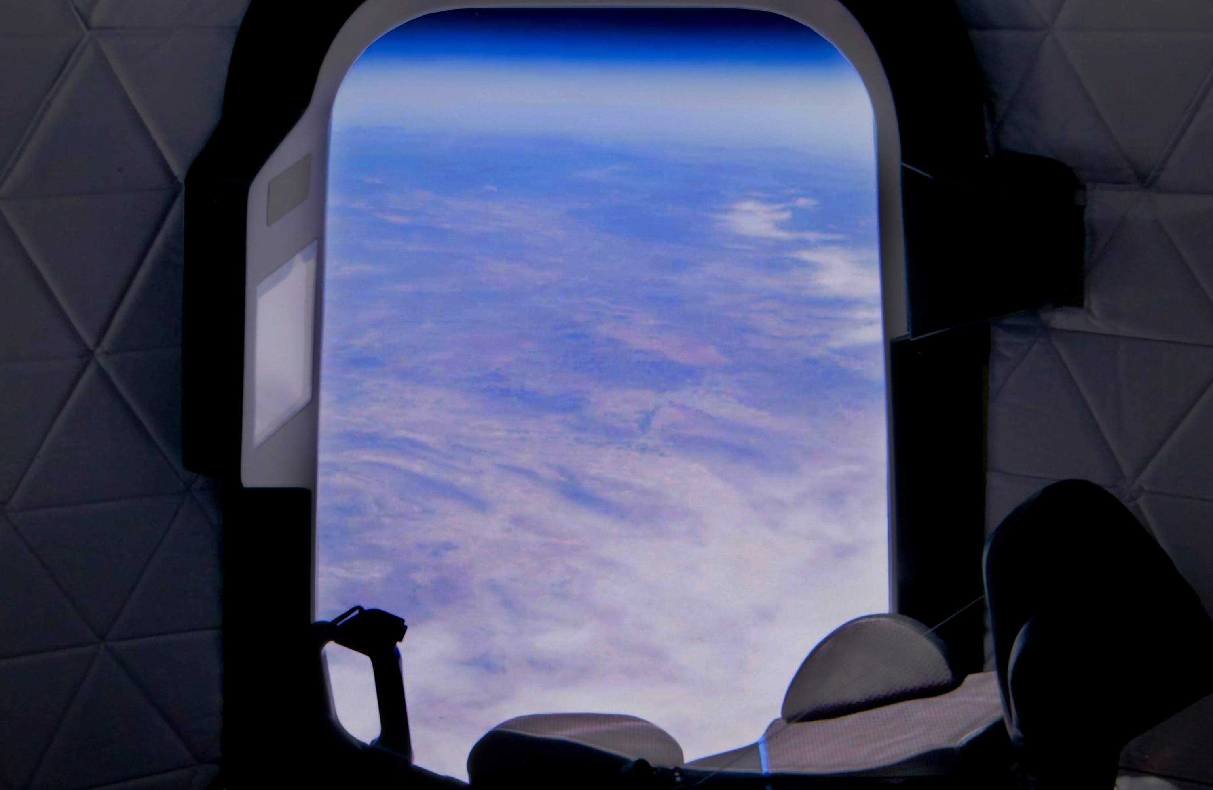
MAY 18, 2022
NEWS

NS-21 to Fly Six Customer Astronauts, Including First Mexican-Born Woman to Visit Space
May 18 During our final vehicle check-outs, we observed one of New Shepard's back-up systems was not meeting our

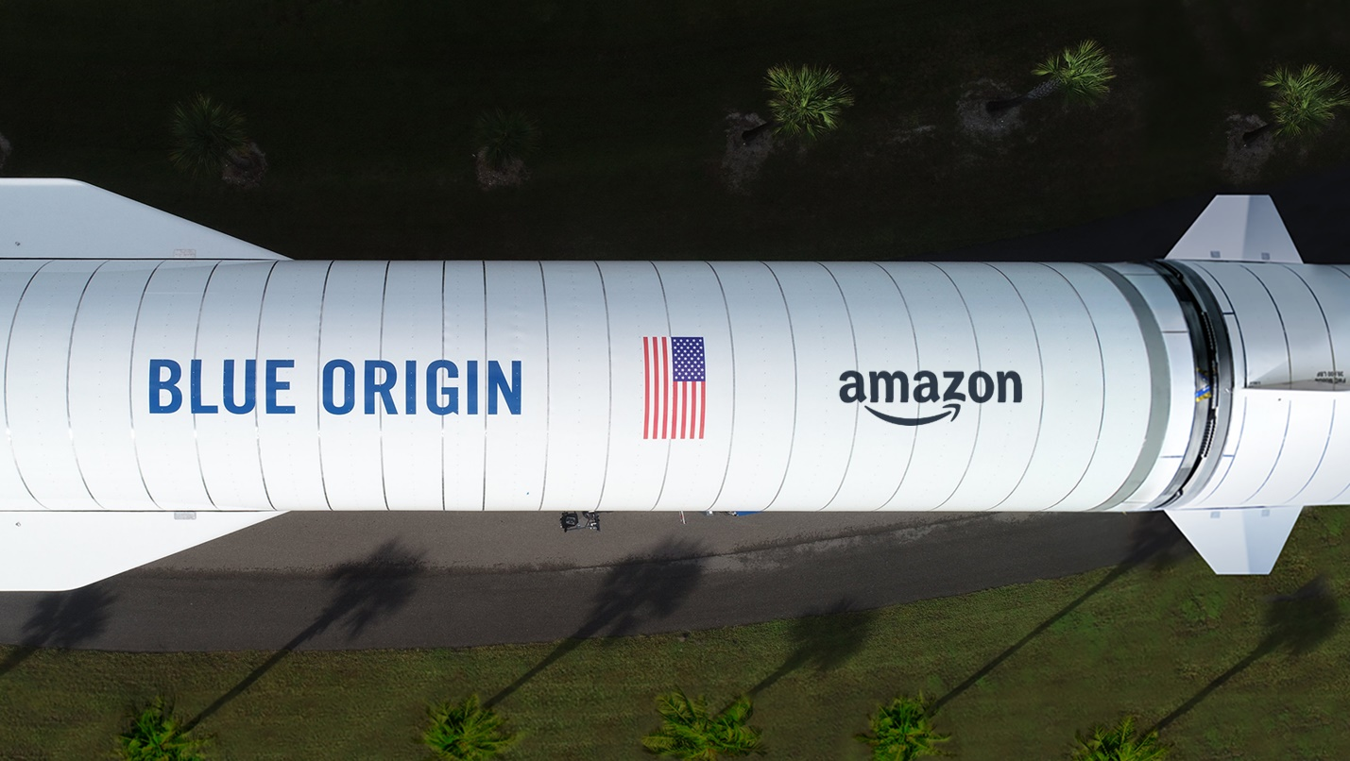
APR 5, 2022
NEWS

Amazon Selects Blue Origin’s New Glenn for up to 27 Project Kuiper Constellation Launches
Blue Origin today announced New Glenn has been selected for 12 launches, with options for up to 15 additional launches

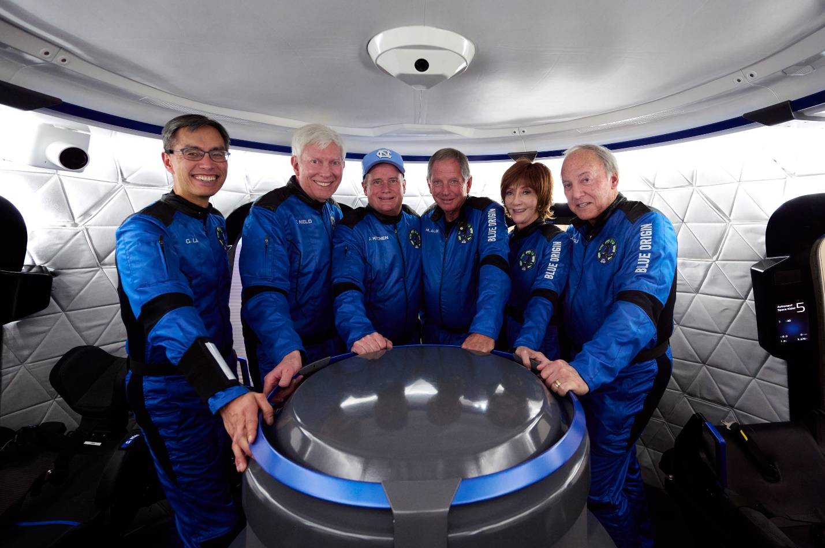
MAR 31, 2022
NEWS

Blue Origin Successfully Completes Fourth Human Spaceflight
March 31, 2022Today, Blue Origin successfully completed its fourth human spaceflight and 20th overall flight for New

MAR 21, 2022
NEWS

Blue Origin's 20th Mission to Space
March 21Blue Origin today announced the sixth crew member joining New Shepard’s 20th mission will be Blue Origin’s Gary

